Cognos Report Studio.

Lab Guide

Table of Contents

Lab 01 - Remove Identical Values in a List 4
Lab 02 - Repeat a Column Value in a List 6
Lab 03 - Create a Discontinuous Crosstab 8
Lab 04 - Add Aggregate Data to a Crosstab Report 10
Lab 05 - Create a Column Chart to Plot Order Trends 12
Lab 06 - Customize the Palette in the Order Trends Chart 14
Lab 07 - Change the Background of the Order Trends Chart 15
Lab 08 - Add a Baseline to the Order Trends Chart 16
Lab 09 - Add a Note to the Order Trends Chart 17
Lab 10 - Format the Axis Values of the Order Trends Chart 18
Lab 11 - Create a Drill-through Chart 19
Lab 12 - Show Values in the Chart Legend 20
Lab 13 - Customize the Axis Titles 23
Lab 14 - Create a Conditional Palette 25
Lab 15 - Create a Map Report 27
Lab 16 - Define Data Values for the Region Layer 29
Lab 17 - Create Mailing Labels 30
Lab 18 - Add a Table of Contents to a Report 32
Lab 19 - Add a Multimedia File to a Report 35
Lab 20 - Preparing a Product List Report 36
Lab 21 - Create a Report Showing Products Returned for a Specific Time Interval 38
Lab 22 - Create a Two-column List Report for Three Data Items 41
Lab 23 - Create a Crosstab Report that Shows Empty Rows 43
Lab 24 - Example - Burst a Report 45
Lab 25 - Create a Conditional Report 47
Lab 26 - Create a Drill-through Report 49
Lab 27 - Create a Drill-up/Drill-down Report 51
Lab 28 - Try It Yourself - Create a List Report 52
Lab 29 - Try It Yourself - Create a Crosstab 54
Lab 30 - Try It Yourself - Create Charts 56
Lab 31 - Try It Yourself - Create Map Reports 70

Lab 32 - Try It Yourself - Add Prompts 74
Lab 33 - Try It Yourself - Create a Multiple-Page Report 76
Lab 34 - Try It Yourself - Create a Template 78
Lab 35 - Try It Yourself - Create an Invoice 80

Lab 01 - Remove Identical Values in a List

- Objective :

You are a report author at The Great Outdoors Company, which sells sporting equipment. You are requested to create a report that lists all product orders, organized by order number. To make the report easy to read, you group the Order number column so that only one instance of each order number appears. However, because each order contains different products, the same order date appears for each product. You decide to show the order date only when the order number changes.

- Steps

- In the Cognos Connection Welcome page, click the Public Folders link.
- Click the GO Sales and Retailers link, and then click the Report Studio link at the upper right corner of the page.
- In the Welcome dialog box, click Create a new report.
- In the New dialog box, click List and click OK.
- In the Insertable Objects pane, on the source tab, add the following data items to the list by double-clicking them:
  - Order number
  - Order date
  - Product name
  - Quantity
  - Revenue
Tip: You can find these data items in the Orders and Products folders.
- Group the Order number column.
- Click the Order date column.
- In the Properties pane, click the Group Span property and then click Order number.
When you run the report, the first row of the Order date column appears for each Order number row.
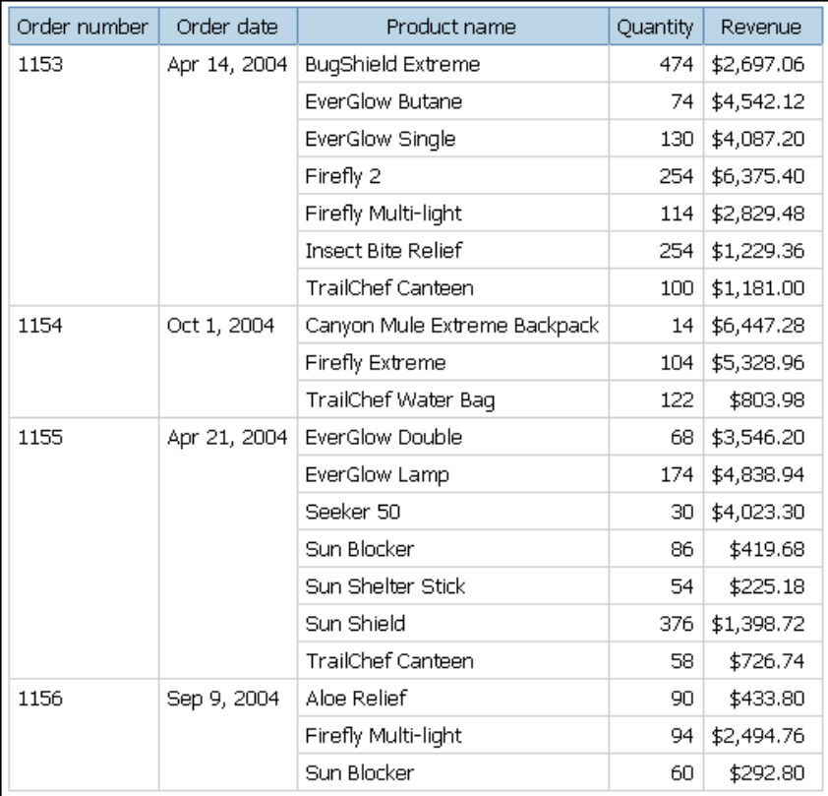

Lab 02 - Repeat a Column Value in a List

- Objective :

You are a report author at The Great Outdoors Company, which sells sporting equipment. You
are requested to create a report that lists all products sold by the company, organized by the
product line and product type. To make the report easier to read, you group the Product line and
Product type columns so that only one instance of each column appears. However, because some
product lines contain many different product types and products, you decide to show the product
line for each product type.

- Steps

- In the Cognos Connection Welcome page, click the Public Folders link.
- Click the GO Sales and Retailers link, and then click the Report Studio link at the upper right corner of the page.
- In the Welcome dialog box, click Create a new report.
- In the New dialog box, click List and click OK.
- In the Insertable Objects pane, on the source tab, add the following data items to the list by double-clicking them:
  - Product line
  - Product type
  - Product name
  - Description
  - Production cost
Tip: You can find these data items in the Products folder.
- Group the Product line and Product type columns.
- Click the Product Name column.
- In the Properties pane, click the Group Span property and click Product type.
- Click any part of the list and then click the select ancestor button in the title bar of the Properties pane.
- Click List.
- In the Properties pane, double-click the Font property.
- In the Size box, click 8pt and click OK.
When you run the report, the product line appears whenever the product type changes.

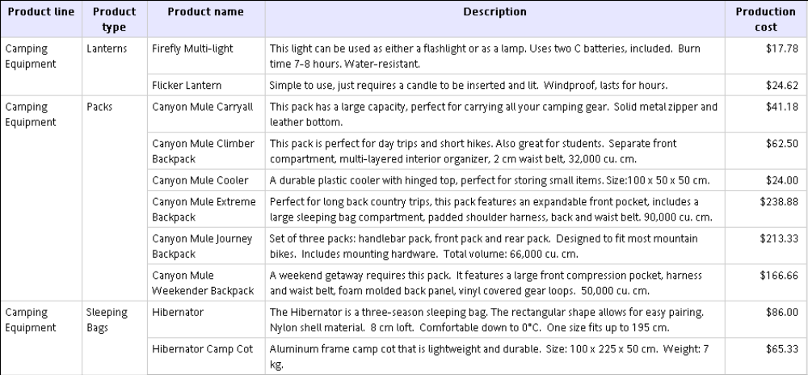

Lab 03 - Create a Discontinuous Crosstab

- Objective :

You are a report author at The Great Outdoors Company, which sells sporting equipment. You
are requested to create a report showing sales for each product line by quarter and by order
method. Since the report will have columns with data from different dimensions, you create a
discontinuous crosstab report. Discontinuous crosstabs are also known as disconnected or disjoint
crosstabs, or crosstabs with unrelated columns.

- Steps

- In the Cognos Connection Welcome page, click the Public Folders link.
- Click the GO Sales and Retailers link, and then click the Report Studio link at the upper right corner of the page.
- In the Welcome dialog box, click Create a new report or template.
- In the New dialog box, click Crosstab and click OK.
- In the Insertable Objects pane, on the source tab, drag the following data items to the crosstab:
  - Product line from Products to Rows
  - Order method from Orders to Columns
  - Revenue from Orders to Measures
- Pause the pointer over the query explorer button and click Query1.
- In the Insertable Objects pane, on the toolbox tab, drag Data Item to the Data Items pane.
The Data Item Expression dialog box appears.
- In the Expression Definition box, type the following and click OK:
CASE
WHEN [gosales_goretailers].[Orders].[Order month] between 1 and 3 THEN 'Q1'
WHEN [gosales_goretailers].[Orders].[Order month] between 4 and 6 THEN 'Q2'
WHEN [gosales_goretailers].[Orders].[Order month] between 7 and 9 THEN 'Q3'
ELSE 'Q4'
END
- In the Properties pane, double-click the Name property, rename the data item Quarters, and press the Enter key.
- Pause the pointer over the page explorer button and click Page1.
- In the Insertable Objects pane, on data items tab, drag Quarters to the left of Order method.
Tip: Make sure the pointer is directly beside Order method before you drop Quarters.
Otherwise, Quarters may appear as a nested row instead of a column.
- Click Quarters.
- In the Properties pane, double-click the Sorting property.
- From the Data Items pane, drag Quarters to the Sort List pane.
- Click the sort order button to sort quarters in ascending order.
- Run the report.
All four quarters are followed by the order methods.

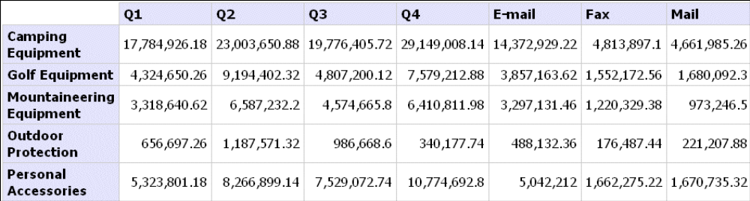

Lab 04 - Add Aggregate Data to a Crosstab Report

- Objective :

You are a report author at The Great Outdoors Company, which sells sporting equipment. You
are requested to create a report showing sales by order method to determine which methods are
generating the most revenue and the highest sales volume.

- Steps

- In the Cognos Connection Welcome page, click the Public Folders link.
- Click the GO Sales and Retailers link, and then click the Report Studio link at the upper right corner of the page.
- In the Welcome dialog box, click Create a new report.
- In the New dialog box, click Crosstab and click OK.
- In the Insertable Objects pane, on the source tab, add the following data items to the crosstab:
  - Double-click Order method to add it as columns.
  - Double-click Product line to add it as rows.
  - Click Product type and drag it just to the right of Product line.
Product type is now nested in Product line.
  - Double-click Quantity to add it as a measure. Drag the Quantity just below Order method
  - Double-click Revenue to add it as a second measure. Drag the Revenue just beside the Quantity.
Tip: You can find these data items in the Orders and Products folders.
Drag the
- Click any part of the crosstab and then click the select ancestor button in the title bar of the Properties pane.
- Click Crosstab.
- In the Properties pane, double-click the Font property.
- In the Size box, click 8pt and click OK.
- Click one of the measures.
- Click the aggregate button and click Maximum.
When you run the report, you can see that for the Special order method, the personal accessory Knives generated the highest sales volume, and Watches generated the most revenue. By sales visit, Knives generated the largest sales volume. Watches ordered by the Telephone order method generated the largest revenue.
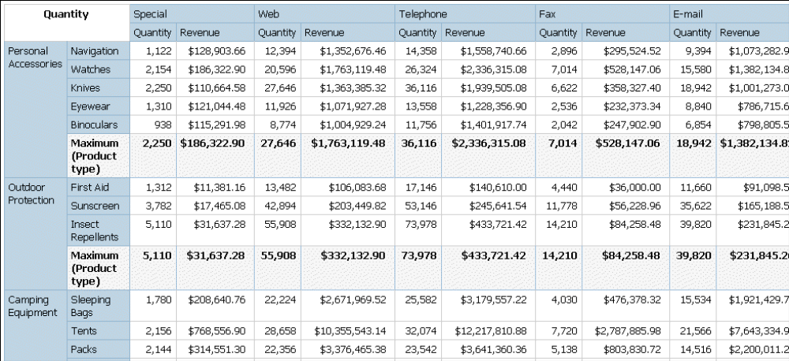

Lab 05 - Create a Column Chart to Plot Order Trends

- Objective :

You are a report author at The Great Outdoors Company. You are requested to create a chart that
shows the contribution that each order method makes to revenue. You decide to create a column
chart because it emphasizes the values of each order method for each year.

- Steps

- In Cognos Connection, go to the GO Sales and Retailers package.
- Click the Report Studio link.
Report Studio starts.
- From the File menu, click New.
- Click Chart and click OK.
- In the Chart group pane, click Column.
- In the Chart type pane, click Column with 3-D Visual Effect.
- Click OK.
- In the Insertable Objects pane, on the source tab, expand Orders and add the following data:
  - Drag Revenue to the Measure (y-axis) drop zone.
  - Drag Order year to the Series drop zone.
  - Drag Order method to the Categories (x-axis) drop zone.
- Click the Order Year icon in the Series drop zone, and then from the Data menu, click Sort Ascending.
- Save the chart:
  - In the Name box, type
Order Trends
  - Leave the default destination folder as Public Folders, and click OK.
- Click the run button on the toolbar, and view the report.

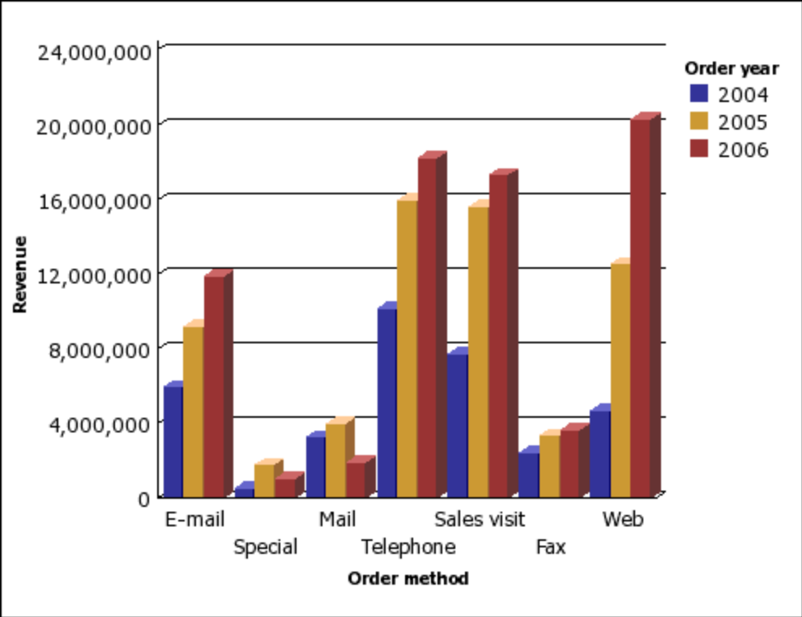

Lab 06 - Customize the Palette in the Order Trends Chart

- Objective :

You are a report author at The Great Outdoors Company. You have created a column chart that
shows the contribution each order method makes to revenue.
You decide to give each column a distinctive look to better differentiate the values of each order
method for each year.
Before you can try this example, you must create the chart in "Example - Create a Column Chart
to Plot Order Trends".

- Steps

- Open the Order Trends chart.
- Click the chart object.
- In the Chart Annotations section of the Properties pane, click the ellipsis points (...) of the Palette property.
- Click the Color link.
- On the Web Safe Colors tab of the Color dialog box, click a medium blue color.
- Click OK.
- Click the new palette entry button, and then click Gradient.
- In the Direction list, click Down.
- Click the From color link.
- On the Web Safe Colors tab of the From Color dialog box, click a medium blue color and click OK.
- Click the To color link.
- On the Web Safe Colors tab of the To Color dialog box, click a lighter blue color and click OK.
- Click the new palette entry button, and then click Pattern.
- In the Pattern box, click a diagonal line pattern.
- Click the Foreground color link.
- On the Web Safe Colors tab of the Foreground Color dialog box, click a blue color and click OK.
- Click OK again to close the Palette dialog box.
Now you must add borders to the diagonal line pattern.
- Click the chart type icon in the Series drop zone.
- In the General section of the Properties pane, change Borders from Hide to Show.
- Save the chart.

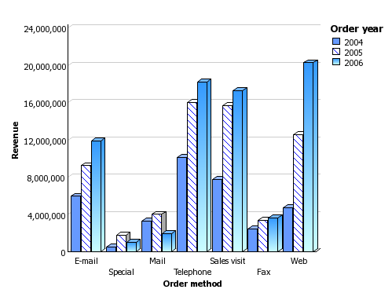

Lab 07 - Change the Background of the Order Trends Chart

- Objective :

You are a report author at The Great Outdoors Company. You created a column chart that shows
the contribution that each order method makes to revenue.
You decide to give your chart a visually interesting background fill.
Before you can try this example, you must create the chart in "Example - Customize the Palette in
the Order Trends Chart"

- Steps

- Open the Order Trends chart.
- Click the chart object.
- Click the lock icon in the toolbar to unlock the chart object, select the chart body by clicking between the axes, and in the Properties pane, under Color & Background, click the ellipsis points (...) of the Fill Effects property.
- In the Effect list, click Gradient.
- Specify a gradient that goes from yellow to white:
  - In the Direction list box, click Up.
  - Click the From color link.
  - On the Web Safe Colors tab, click a light yellow color and click OK.
  - Leave white as the To color.
- Click OK.
- Save the chart.

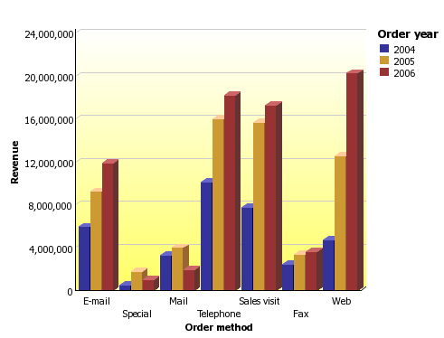

Lab 08 - Add a Baseline to the Order Trends Chart

- Objective :

You are a report author at The Great Outdoors Company. You created a column chart that shows
the contribution that each order method makes to revenue.
You decide to add a baseline to indicate the mean revenue for the Order Trends chart.
Before you can try this example, you must create the chart in "Example - Change the Background
of the Order Trends Chart"

- Steps

- Open the Order Trends chart.
- Click the chart object.
- In the Chart Annotations section of the Properties pane, click Baselines, and then click the ellipsis points (...).
- Click the new button.
- Click the Data Mean type in the list, leave Distance From Mean at zero, and click OK twice.
A baseline icon appears in the Markers, Notes, and Baselines box.
- Click the baseline icon to define the line style.
- In the General section of the Properties pane, change the Line Color to Red.
- In the General section of the Properties pane, change the Line Style to Dash.
- Save the chart.

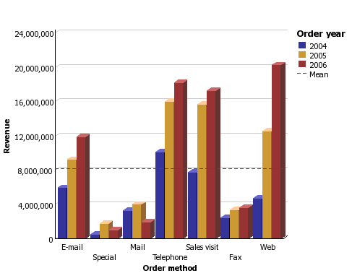

Lab 09 - Add a Note to the Order Trends Chart

- Objective :

You are a report author at The Great Outdoors Company. You created a column chart that shows
the contribution that each order method makes to revenue.
You decide to add a note to draw attention to an unexpected result.
Before you can try this example, you must create the chart in "Example - Add a Baseline to the
Order Trends Chart"

- Steps

- Open the Order Trends chart.
- Click the chart object.
- In the Chart Annotations section of the Properties pane, click Notes, then click the ellipsis points (...).
The Notes dialog box appears.
- Click the new button, and then click OK.
A note icon appears in the Markers, Notes, and Baselines section.
- Click the note icon.
- In the General section of the Properties pane, change Bottom Position to 285 and Left Position to 110.
The location and size are statically set based on the number of pixels.
- In the General section of the Properties pane, click Note Border, then click the ellipsis points (...).
- Select the Note border check box, click a line color and line style, and then click OK.
- Run the report to view the note.
If necessary, change the position again.
- Double-click the note text icon and type
Fax orders increased when declines were expected.
- Save the chart.
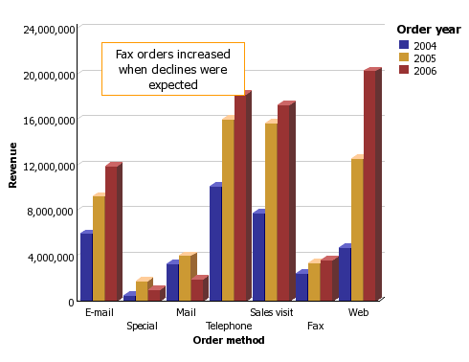

Lab 10 - Format the Axis Values of the Order Trends Chart

- Objective :

You are a report author at The Great Outdoors Company. You created a column chart that shows
the contribution that each order method makes to revenue.
You decide to format the y-axis values to make them easier to read.
Before you can try this example, you must create the chart in "Example - Add a Note to the Order
Trends Chart" .

- Steps

- Open the Order Trends chart.
- Click the y-axis icon.
- In the Data section of the Properties pane, click Data Format, and then click the ellipsis points (...).
- Under Format type, click Number.
- Under Properties, click Scale, in the drop-down list click -3, and click OK.
- Expand Axis titles.
- Double click the y-axis title icon and type
Revenue (thousands)
- Save the chart.

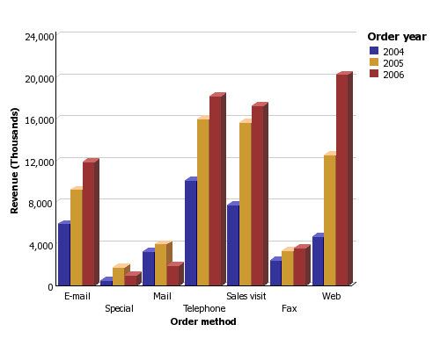

Lab 11 - Create a Drill-through Chart

- Objective :

You create a drill-through report to link two reports containing related information. You can then access related or more detailed information in one report by selecting a value in the chart. You are a report author at The Great Outdoors Company, which sells sporting equipment. You are requested to create a chart that shows the revenue for each product line and allows the reader to drill through from the revenue chart to view the product details for any item selected. You create two reports, a target list report that contains the details for the item, and a source chart that shows the product line revenue. For more information about using drill-though reporting in Report Studio, see "Create a Drill-through Report"

- Steps to Create the Target Report

- In the Cognos 8 Welcome page, click the Report Studio link.
- Select the package GO Sales and Retailers.
- In the Welcome dialog box, click Create a new report or template.
- In the New dialog box, click List and click OK.
- In the Insertable Objects pane, on the source tab, add the following data items to the list by double-clicking them:
  - Product line
  - Product type
  - Product name
  - Description
  - Introduction date
  - Product image
Tip: You can find these data items in the Products.
Now you must create a filter to uses as a drill-through parameter. A drill-through parameter begins and ends with a question mark (?) symbol.
- Click the filters button.
- Click the add button and type the following in the Expression Definition window: [gosales_goretailers].[Products].[Product line]=?p_PL?
- Click OK.
- Save the report as Product Line Details.

- Steps to Create the Source Chart

- Create a new report.
- In the New dialog box, click Chart and click OK.
- In the Chart group pane, click Column.
- In the Chart type pane, click Column.
- Click OK.
- In the Insertable Objects pane, on the source tab, expand Orders.
- Drag Revenue to the Measure (y-axis) drop zone.
- Drag Order method to the Series drop zone.
- Expand Products and drag Product Line to the Categories (x-axis) drop zone.
- From the Data menu, click Drill Behavior.
- In the Basic tab, in the Report Drill Capabilities, select the Allow drill through from a package check box.
- Click OK.
- Right-click the chart object and click Drill Throughs.
- Click the New Drill Through button.
- Under Report, select the Product Line Details report you created previously and click Open.
- Under Action, select Run the Report.
- Under Format, select HTML.
- Click the edit button.
Any existing drill-through parameters appear. You see the parameter you created for Product Line Details.
- For item p_PL, under Method click Pass data item value, and under Value, click Product line.
- Click OK twice.
- Save the chart as Product Revenue.
- Click Run.
When the report is run, the list will show the product lines as clickable links. When a product line is clicked, the second report will be run for that product line.

Lab 12 - Show Values in the Chart Legend

- Objective :

You are a report author at The Great Outdoors Company. You are requested to create a chart that
shows the quantity of items sold for each product line by order method. To show how much the
quantity represents in revenue, you want to show the revenue for each order method in the legend.

- Steps

- In Colognes Connection, go to the GO Sales and Retailers package.
- Click the Report Studio link.
Report Studio starts.
- From the File menu, click New.
- Click Chart and click OK.
- In the Chart group pane, click Column.
- In the Chart type pane, click Column.
- Click OK.
- In the Insertable Objects pane, on the source tab, expand Orders.
- Drag Quantity to the Measure (y-axis) drop zone.
- Drag Order method to the Series drop zone.
- Expand Products and drag Product Line to the Categories (x-axis) drop zone.
- From the Structure menu, clear Lock Page Objects.
If you do not clear Lock Page Objects, you will be unable to insert a text item in the legend.
- In the Insertable Objects pane, on the toolbox tab, drag a text item into the legend next to Order method.
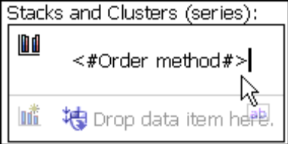

- In the Text box, type - Revenue:
You must insert a trailing space after the colon.
- In the Insertable Objects pane, on the source tab, drag Revenue to the right of the text item.

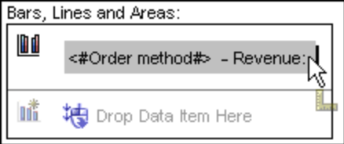

- Click the run button on the toolbar, and view the report.
The revenue is listed beside each legend item.
Tip: To reposition the legend in the chart, click the legend icon, change the Absolute Position property to Yes, and specify the Left Position and Top Position values.
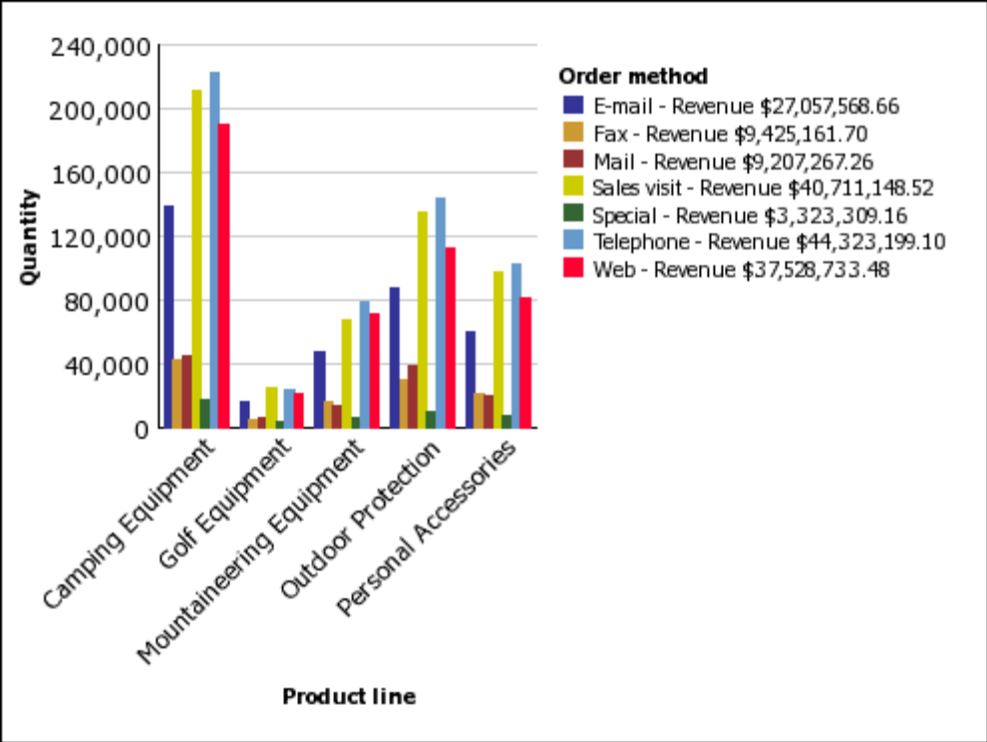

Lab 13 - Customize the Axis Titles

- Objective :

You are a report author at The Great Outdoors Company. You are requested to create a chart that
shows the total revenue for the report in the horizontal axis title.
Charts contain several titles, such as axis titles, report titles and subtitles, and the legend title.
By default, the axis titles are managed for you. To customize an axis title, you drag text items or
data items to the axis title area in the chart. You can use combinations of text, data items, and
report expressions in titles.

- Steps

- In Cognos Connection, go to the GO Sales and Retailers package.
- Click the Report Studio link.
Report Studio starts.
- From the File menu, click New.
- Click Chart and click OK.
- In the Chart group pane, click Column.
- In the Chart type pane, click Column.
- Click OK.
- In the Insertable Objects pane, on the source tab, expand Orders.
- Drag Revenue to the Measure (y-axis) drop zone.
- Drag Order method to the Series drop zone.
- Expand Products and drag Product line to the Categories (x-axis) drop zone.
- Expand Axis titles.
- Click the horizontal axis title icon.
Tip: You can use the Properties pane to change the axis title properties, such as font & text, positioning, color & background, and so on.
- In the Insertable Objects pane, on the toolbox tab, drag a text item into the horizontal axis text.
- In the Text box, type
Product Line - Total Revenue:
You must insert a trailing space after the colon.
- In the Insertable Objects pane, on the toolbox tab, drag a query calculation to the right of the text.

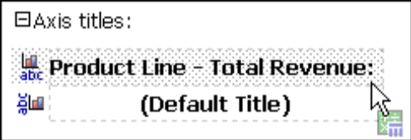

- In the Create Calculation dialog box, type Total Revenue for Report
- Click OK.

- In the Expression Definition box, type the expression:
total ([Revenue] for report)
- Click the run button on the toolbar, and view the report.
The title shows the calculated total revenue for Product line.
Tip: You can use conditional formatting to conditionally style the titles.

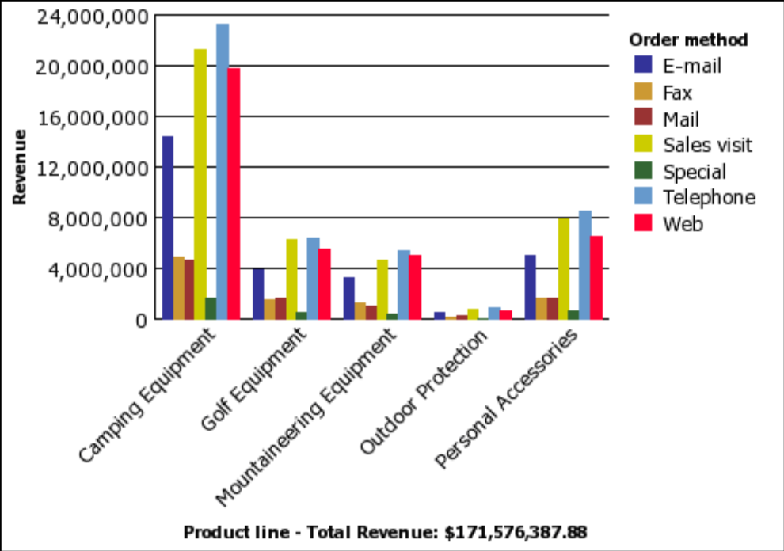

Lab 14 - Create a Conditional Palette

- Objective :

You are a report author at The Great Outdoors Company. You are requested to create a chart that
shows one pie slice for each order method. You also want to highlight the pie slice for the order
method that has the highest quantity.
You create a condition that shows you which order method has sold a quantity greater than
550,000.

- Steps

- In Cognos Connection, go to the GO Sales and Retailers package.
- Click the Report Studio link.
Report Studio starts.
- From the File menu, click New.
- Click Chart and click OK.
- In the Chart group pane, click Pie, Donut.
- In the Chart type pane, click Pie.
- Click OK.
- In the Insertable Objects pane, on the source tab, expand Orders.
- Drag Quantity to the Measure drop zone.
- Drag Order method to the Pie Slices drop zone.
You want to create a condition that shows you which order method has sold a quantity greater than 550,000.
- Select the pie chart.
- In the Chart Annotations section of the Properties pane, open the Conditional Palette properties dialog box.
- Under Variable, select <New Boolean Variable>.
- In the New Variable dialog box, type HighQuantity
- Click OK.
- In the Expression Definition box, type the expression:
[Query1].[Quantity] > 550000
- Click OK to close the expression editor. Leave the Conditional Palette dialog box open.
You want to use a pattern to highlight the best performing order method.
- Under Effect, click Pattern.
- Under Pattern, click a pattern.
- Click OK.
- In the General section of the Properties pane, change the Borders property from Hide to Show.
- Run the report.
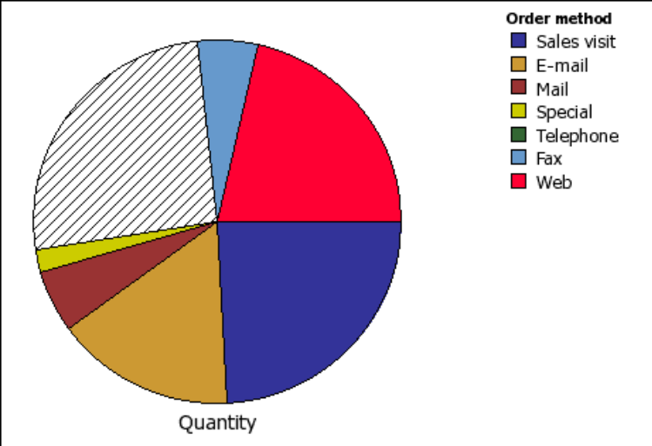

Lab 15 - Create a Map Report

- Objective :

You are a report author at The Great Outdoors Company. You are asked to show how revenue for
the company is distributed throughout the world. This information can be shown in tabular
format using a list report, but a map will create a more meaningful presentation. You decide to
create a report that contains a map of the world showing the distribution of revenue by country.

- Steps

- In Cognos Connection, go to the GO Sales and Retailers package.
- Click the Report Studio link.
Report Studio starts.
- From the File menu, click New.
- Click Map and click OK.
- In the Choose Map dialog box, in the Maps pane, expand World and click World Countries.
- In the Region Layers box, click World Countries.
- In the Point Layers box, click None.
- In the Display Layers box, click Grid.
- Click OK.
Tip: You can return to the Choose Map dialog box at any time by double-clicking the map background.
    - title
    - subtitle
    - Footer
    - map object (anywhere within frame)
    - legend title
    - legend icon
- Click the run button on the toolbar, and view the map plus the grid from the display layer.

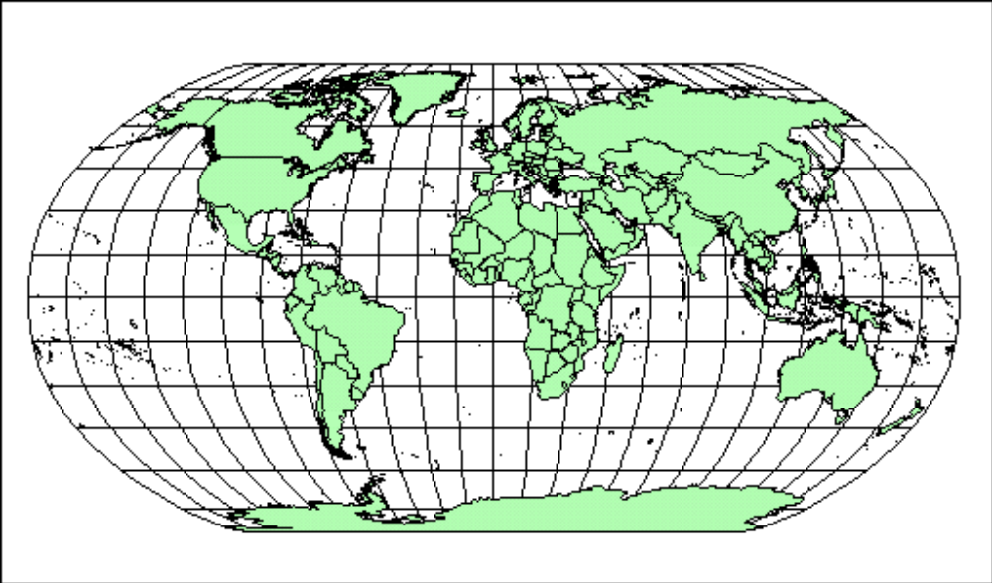

Lab 16 - Define Data Values for the Region Layer

- Objective :

The map that you created in the previous topic is not yet linked to a data source. You will now
specify the data values from your data source that will determine the color of each region.

- Steps

- In the Insertable Objects pane, expand Orders.
- Drag Revenue to the Color drop zone.
- In the Insertable Objects pane, expand Countries.
- Drag Country to the Location drop zone.
- Select the map object.
- In the Properties pane, click Ignore Data with no Features and change the property to Yes. This specifies that the report will run even if there is not a match in the map file for every data value retrieved from the data source. If this property is set to No, then the report will not run and an error message will indicate that the data source contains references to names that are missing from the map file.
- Run the report.

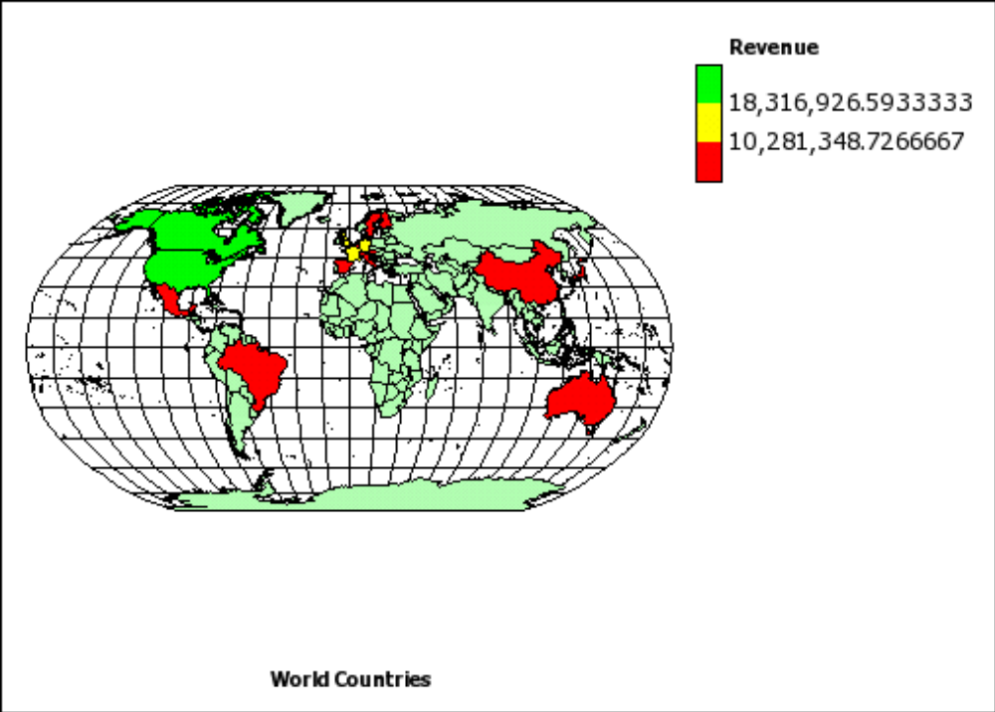

Lab 17 - Create Mailing Labels

- Objective :

You are a report author at The Great Outdoors Company, which sells sporting equipment. You
are requested to create mailing labels for all of the company’s retailers.

- Steps

- In the Cognos Connection Welcome page, click the Public Folders link.
- Click the GO Sales and Retailers link, and then click the Report Studio link at the upper right corner of the page.
- In the Welcome dialog box, click Create a new report.
- In the New dialog box, click Repeater Table and click OK.
- Click the repeater, click the select ancestor button in the Properties pane title bar, and click Repeater Table.
- In the Properties pane, specify properties for the repeater:
  - For the Across property, type 2.
  - For the Down property, type 5.
  - Double-click the Table Properties property, select the Fixed size check box, and click OK.
- In the Insertable Objects pane, on the toolbox tab, drag the Table object to the repeater.
The Insert Table dialog box appears.
- In the Number of columns box, type 1 and click OK.
- Click the table, ensure that you see Table Cell in the Properties pane title bar, and modify the following properties:
  - Double-click Background Image, click Browse, click logo.jpg, and click OK.
  - In the Position box, click the align top right button.
  - In the Tiling box, click Do not tile and click OK.
  - Double-click Size & Overflow, and in the Height box, type 175, and click OK.
- Click the table, click the select ancestor button in the Properties pane title bar, and click Table.
- In the Properties pane, specify properties for the table:
  - Double-click Border.
  - In the Color box, click Black.
  - In the Style box, click Solid line.
  - In the Width box, click 1 pt.
  - Under Preview, click the all borders button and click OK.
  - Double-click Font, and under the Size box, click 8pt, and click OK.
- In the Insertable Objects pane, on the toolbox tab, drag the Block object to the repeater 8 times to create 8 blocks.
- Drag the Text Item object to the first block:
  - In the Text dialog box, type To: and click OK.
  - Click the text item.
  - Click the font button, click Bold, and click OK.
- Click the first block, and, in the Properties pane, specify properties for the first block:
  - Double-click Padding, type 35 in the right box, click mm as the unit, and click OK.
  - Click Horizontal Alignment, and click Center.
- In the Insertable Objects pane, on the source tab, expand Retailers.
- Expand the Mailing address folder, and drag the seven data items to the remaining seven blocks.
- Shift+click the seven blocks to select them, and in the Properties pane, specify properties for the seven blocks:
  - Double-click Padding, type 25 in the left box, click mm as the unit, and click OK.
  - Click Horizontal Alignment and click Left.
When you run the report, each page contains 10 mailing labels in two columns.
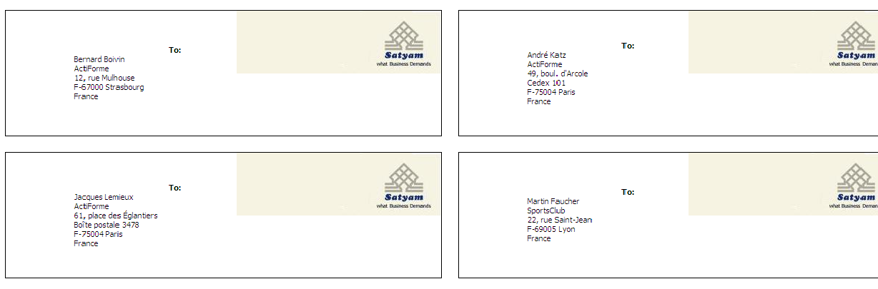

Lab 18 - Add a Table of Contents to a Report

- Objective :

You are a report author at the Great Outdoors Company, which sells sporting equipment. You are
requested to create a report that shows all products sold by the company. To make the report
easier to read, you divide the report into sections for each product line. You add bookmarks so
that users can jump to each product line and back to the top of the report.

- Steps

- In the Cognos Connection Welcome page, click the Public Folders link.
- Click the GO Sales and Retailers link, and then click the Report Studio link at the upper right corner of the page.
- In the Welcome dialog box, click Create a new report or template.
- In the New dialog box, click List and click OK.
- In the Insertable Objects pane, on the source tab, add the following data items to the list by double-clicking them:
Data Item Label Creates a bookmark that has the label of a data item as its value.
Use this source type to jump to the first occurrence of a data item label.
For example, a list is divided into sections using Product line. You want users to jump to the first product line section that appears in the list rather than to a specific section, such as Camping Equipment.
Note: This source type appears only if the bookmark is inserted next to a data item.
Member Caption In a crosstab, creates a dynamic bookmark that uses member captions as possible values.
Cell Value In a crosstab, creates a dynamic bookmark that uses cell values as possible values.
Source type Description
  - Product line
  - Product type
  - Product name
  - Description
  - Production cost
Tip: You can find these items in the Products folder.
- Click the Product line column, and then click the create section button.
- From the Structure menu, click Lock Page Objects.
- In the Insertable Objects pane, on the toolbox tab, drag Bookmark to the left of Product line.
- Click the bookmark, and in the Properties pane, click the Source Type property and click Data Item Value.
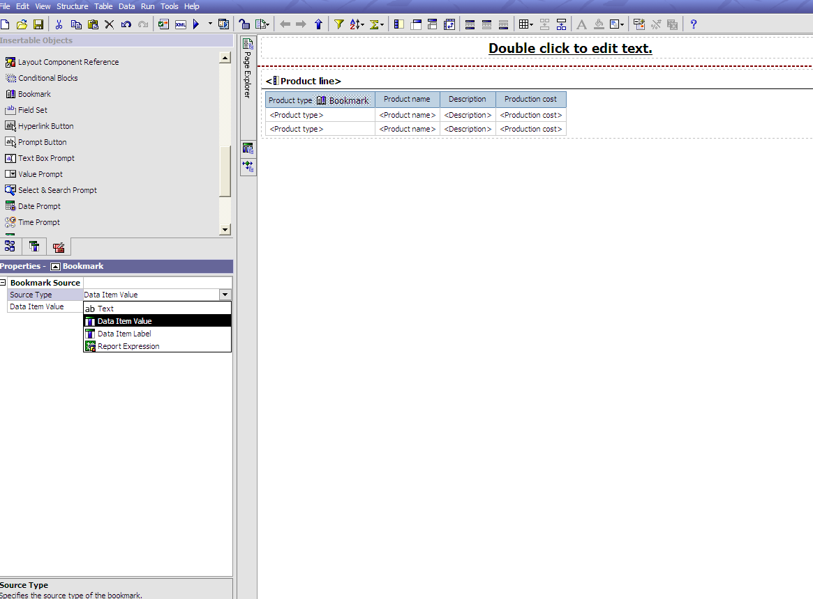

- In the Properties pane, click the Data Item Value property and click Product line.

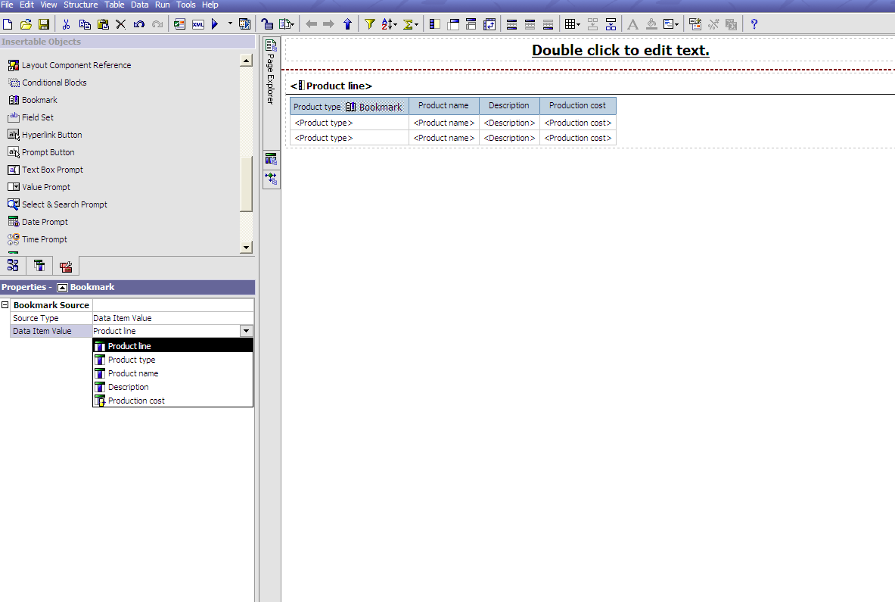

- In the Insertable Objects pane, on the toolbox tab, drag List to the report header.
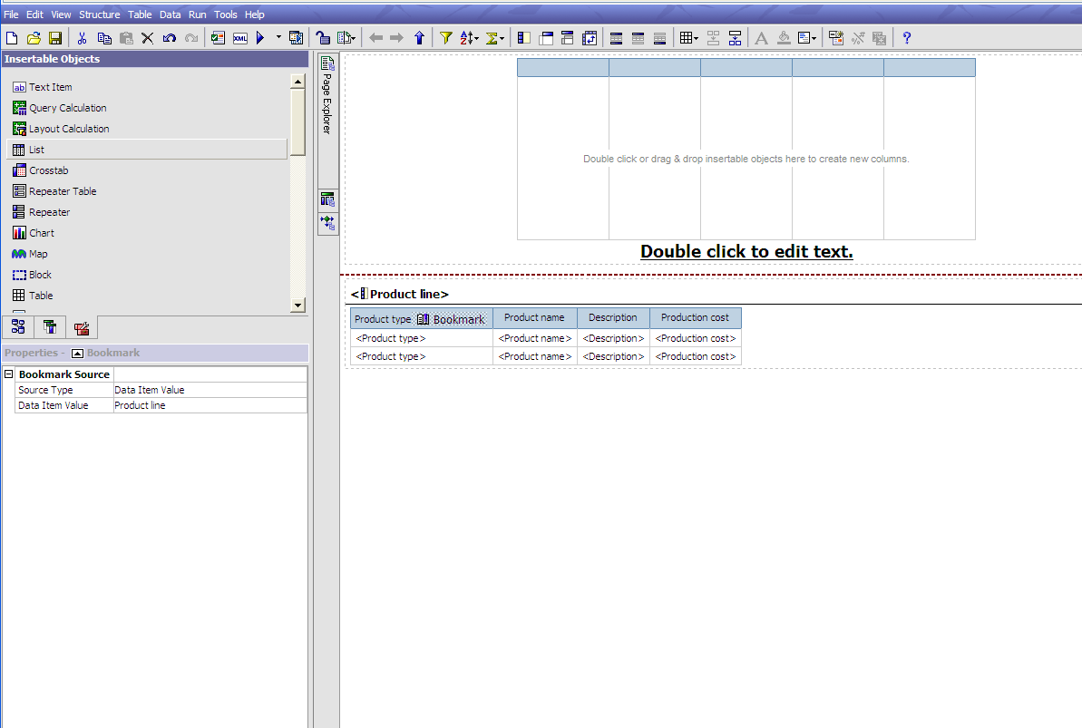

- Click the report header.
- Click the container alignment button, and click align top left.

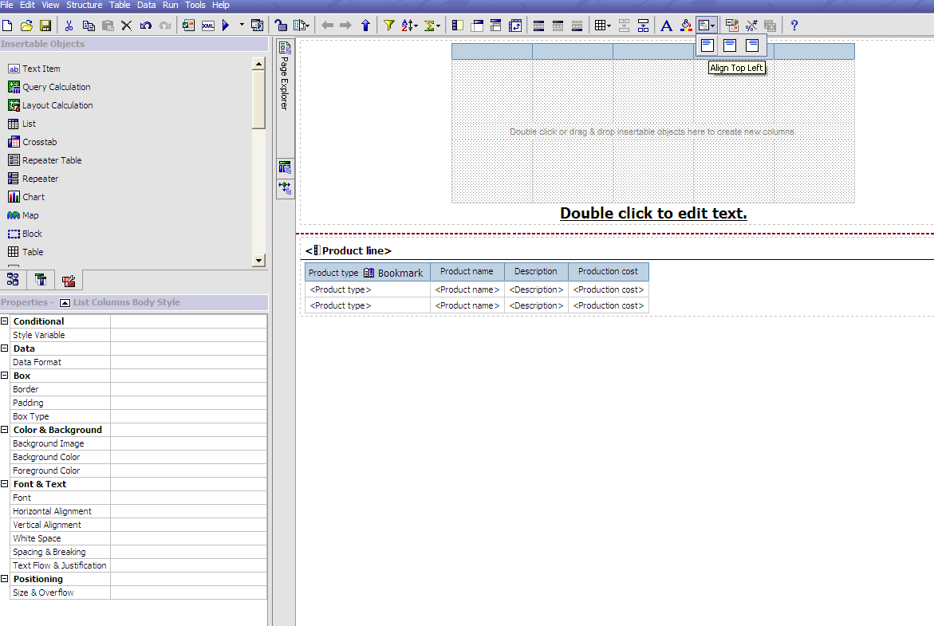
- In the Insertable Objects pane, on the source tab, drag Product line to the new list.
- Right-click Product line and click Drill Throughs.
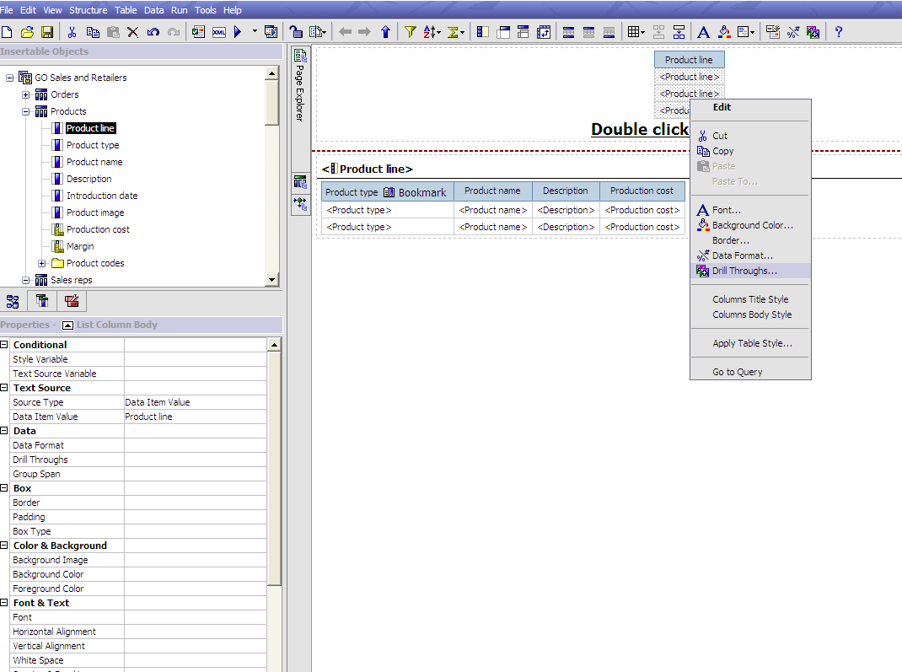

- Click the new drill through button.
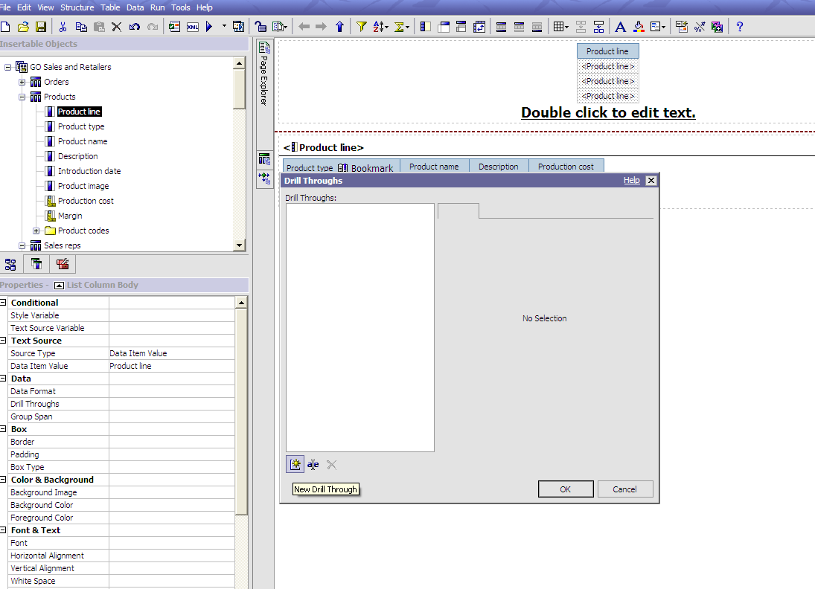

- Click the Bookmark tab.
- Click Source type and then click Data Item Value.
- Click Data Item and then click Product line.
- Click OK.
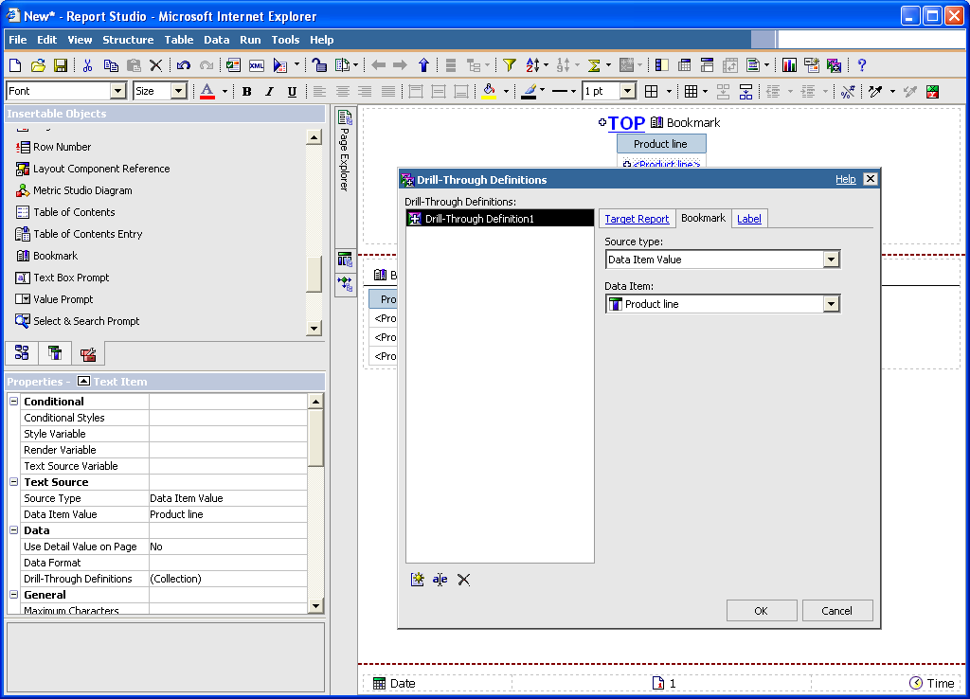

- In the Insertable Objects pane, on the toolbox tab, drag Text Item to the left of the Product line bookmark.
- In the Text dialog box, type Top and click OK.
- Right-click the Top text item and click Drill Throughs.
- Click the new drill through button.
- Click the Bookmark tab.
- Click Source Type and then click Text.
- Click the ellipsis (...) button next to the Text box.
- Type Top and click OK.
- In the Insertable Objects pane, on the toolbox tab, drag Bookmark to the report header.
- Click the bookmark.
- In the Properties pane, click the Source Type property and click Text.
- In the Properties pane, double-click the Label property and type Top
- Click OK.
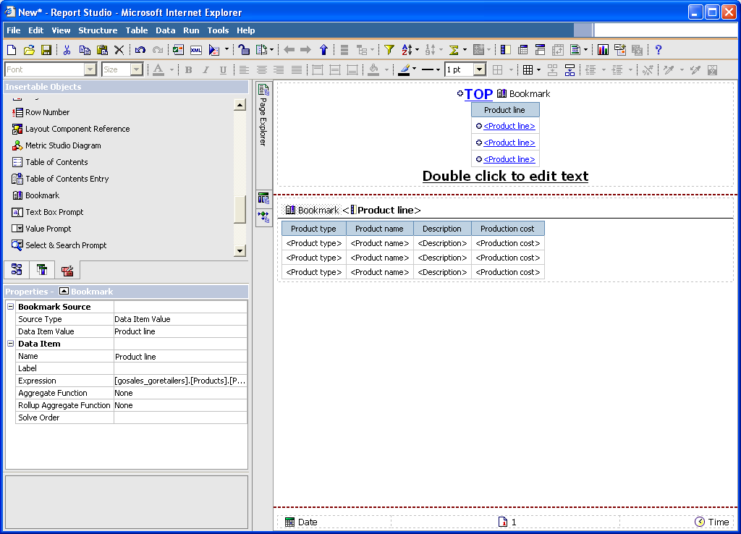

- Save the report.
- In Cognos Connection, click the run with options button for the report.
- Under Delivery, click Save the report.
- Click Run and then click OK.
Tip: The report may take a few minutes to run.
- Under Actions, click View the output versions for this report button for the report.
- Under Formats, click HTML to view the report output.
The report opens in Cognos Viewer.
In the report header, all product lines appear in a list as links. Clicking a product line brings you to the corresponding product line section in the second list. You can return to the top of the report by clicking the Top link next to the section heading.
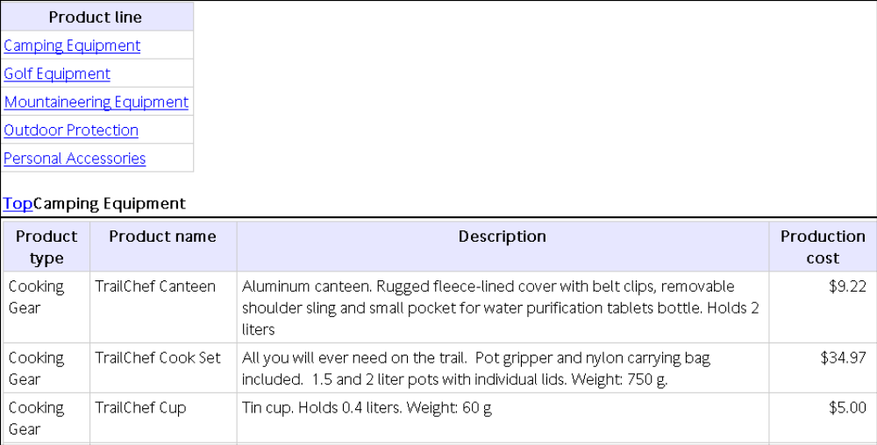

Lab 19 - Add a Multimedia File to a Report

- Objective :

You are a report author at the Great Outdoors Company, which sells sporting equipment. You
want to insert a Windows Media Audio/Video file named GO.wmv in a template that serves as a
cover page for all reports.
You must have Windows Media Player installed on your computer.

- Steps

- In the Cognos Connection Welcome page, click the Public Folders link.
- Click the GO Sales and Retailers link, and then click the Report Studio link at the top right corner of the page.
- In the Welcome dialog box, click Open an existing report.
- In the Open dialog box, click the GO Template Samples folder and then double-click GO Cover Page.
The GO Cover Page report opens.
- In the Insertable Objects pane, on the toolbox tab, drag the HTML Item object to the report.

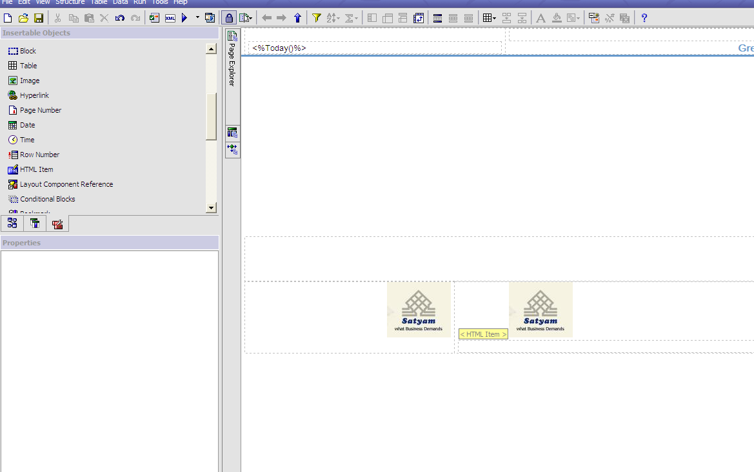

- In the report, select the HTML Item you just added.
- In the Properties pane, double-click the HTML property.
- In the HTML dialog box, type the following:
<OBJECT classid="CLSID:6BF52A52-394A-11D3-B153-00C04F79FAA6">
<PARAM NAME="URL" VALUE="/c8/webcontent/samples/images/GO.wmv"/>
</OBJECT>

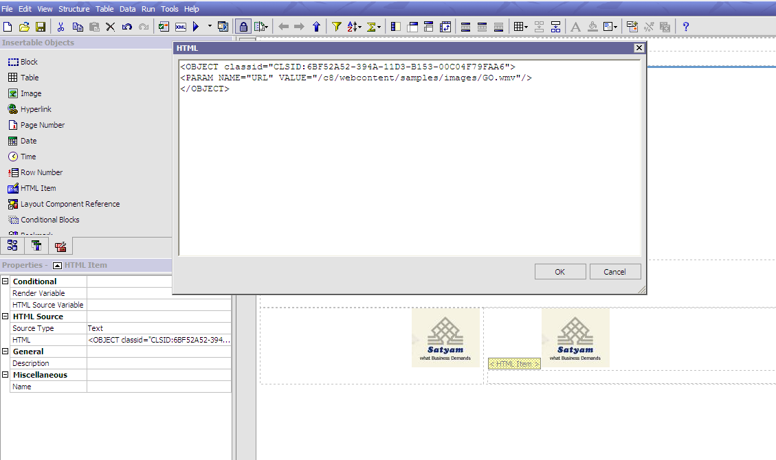

- Click OK.
When you run the report, the multimedia file plays in Windows Media Player.
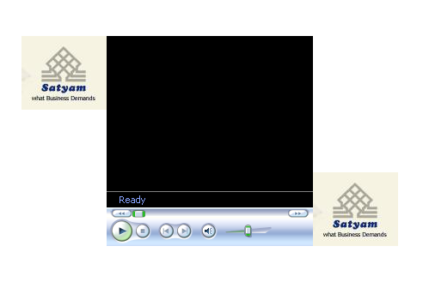

Lab 20 - Preparing a Product List Report

- Objective :

You are a report author at the Great Outdoors Company, which sells sporting equipment. You are
requested to create a multiple-page report showing all products sold by the company. You are
asked to create title and end pages, and to have each product line appear on a new page, preceded
by a header page and followed by a footer page.

- Steps

- In the Cognos Connection Welcome page, click the Public Folders link.
- Click the GO Sales and Retailers link, and then click the Report Studio link at the upper right corner of the page.
- In the Welcome dialog box, click Create a new report or template.
- In the New dialog box, click List and click OK.
- In the Insertable Objects pane, on the source tab, add the following data items to the list by double-clicking them:
  - Product line
  - Product type
  - Product name
  - Description
  - Production cost
Tip: You can find these data items in the Products folder.
- Group the Product line and Product type columns.
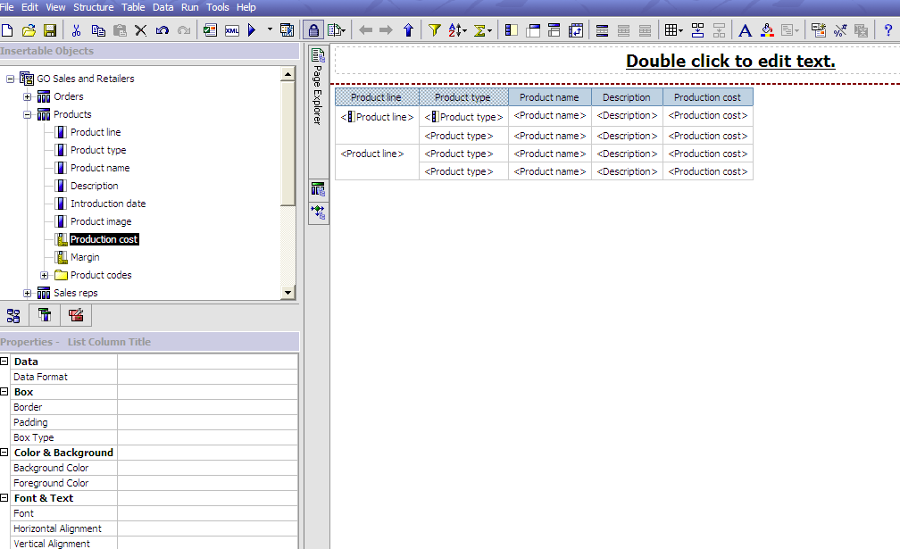

- Pause the pointer over the page explorer button and click Report Pages.

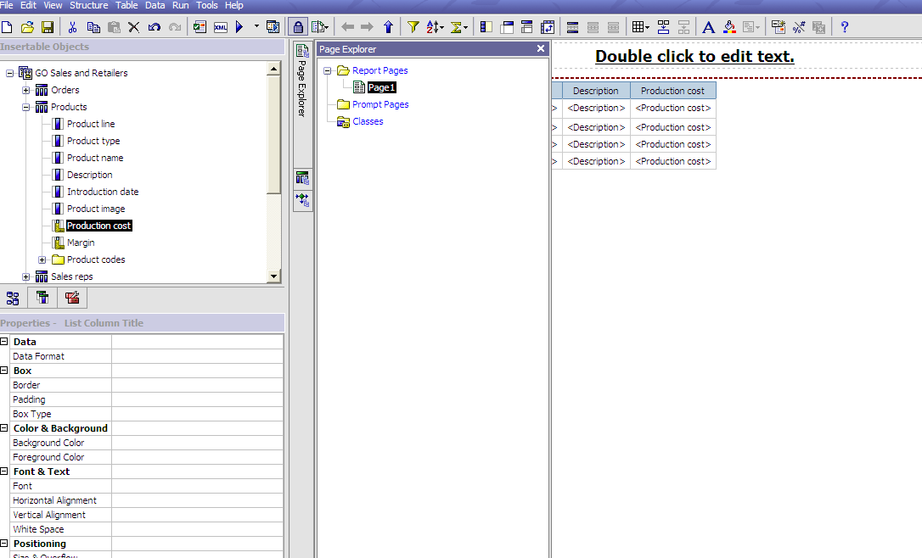

- In the Insertable Objects pane, drag Page Set to the work area and associate it to the query Query1.
- In the Insertable Objects pane, drag Page to the work area four times.
- For each page, click the page, and in the Properties pane, double-click the Name property and name it as follows:
  - Title page
  - End page
  - Product Line Header
  - Product Line Footer
- For each page just created, add the objects you want.
For example, add a text item to each page to uniquely identify it.
- Rename the Page1 page, which contains the list, to List.
- Click the page set, and, in the Properties pane, double-click the Grouping & Sorting property.
- In the Data Items box, drag Product line to the Groups folder in the Groups box and click OK.
- Organize the report pages into the following hierarchy by dragging them to the appropriate location.
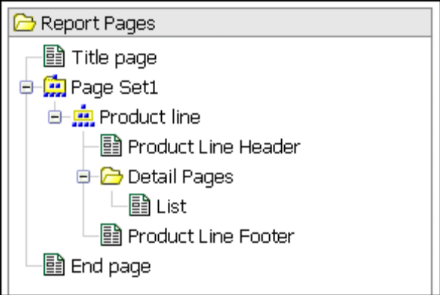

When you run the report, the following pages appear:
  - Title page
  - Product line header page
  - A page for Product line_1
  - Product line footer page
  - Product line header
  - A page for Product line_2
  - Product line footer
  - ...
  - End page

Lab 21 - Create a Report Showing Products Returned for a Specific Time Interval

- Objective :

You are a report author at the Great Outdoors Company, which sells sporting equipment. You are requested to create a report that shows products returned for a time interval specified by the user. Interval Prompt Retrieves data based on a time interval that you specify.
Use this control to retrieve data that is related to the passage of time.

For example, you can use this control to retrieve a list of products that were returned 30 or more days after they were purchased.
Tree Prompt Retrieves data based on values you select from a list. Values are organized hierarchically. This control is useful when you are working with dimensional data sources. Data is shown from the top of a dimension hierarchy to the most detailed member, and users can choose the level of detail they want to view in the report.

Generated Prompt Selects a prompt control based on the data type of the data item. This control acts like a placeholder. When you run the report, the control is replaced by the appropriate prompt control. For example, if you are prompting date values, the control is replaced by a date & time prompt.

- Steps

- In the Cognos Connection Welcome page, click the Public Folders link.
- Click the GO Sales and Retailers link, and then click the Report Studio link at the upper-right corner of the page.
- In the Welcome dialog box, click Create a new report or template.
- In the New dialog box, click List and click OK.
- In the Insertable Objects pane, on the source tab, double-click the following data items to add them to the list:
  - Order number
  - Product name
  - Return quantity
Tip: You can find these items in the Orders and Products folders.
- In the Insertable Objects pane, on the toolbox tab, drag Query Calculation to the right of Return quantity in the list.
- In the Name box, type the following and click OK:
Time Interval
- In the Expression Definition box, type the following and click OK:
[gosales_goretailers].[Orders].[Return date]-[gosales_goretailers].[Orders].[Order date]
- From the Data menu, click Filters.
- Click the add button.
- In the Expression Definition box, type
[gosales_goretailers].[Orders].[Return date]-[gosales_goretailers].[Orders].[Order date] > ?p1?
- Click OK twice.
A parameterized filter is created that will return data when the difference between the return date and the order date is greater than the value specified by the user.
- Pause the pointer over the page explorer button and click Prompt Pages.
- In the Insertable Objects pane, drag Page to the Prompt Pages pane, and then double-click it.
- In the Insertable Objects pane, on the toolbox tab, drag Interval Prompt to the work area.
The Prompt Wizard dialog box appears.
- Click Use existing parameter, and then click p1.
- Click Finish.
- Run the report.
An interval prompt appears.
- In the Days box, type a value and click Finish.
Tip: You can also type values for the Hrs and Mins boxes.
A list report appears, showing all products that were returned after the time interval you specified.
For example, if you type 30 days, the list will show products that were returned more than 30 days after the order date.

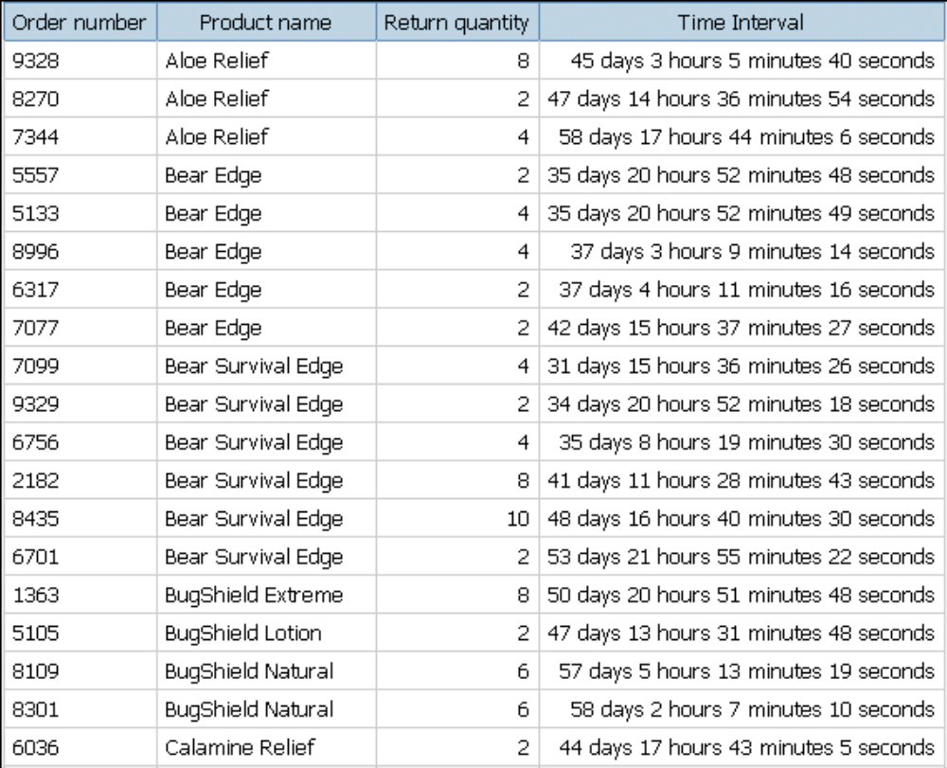

Lab 22 - Create a Two-column List Report for Three Data Items

- Objective :

You are a report author at the Great Outdoors Company, which sells sporting equipment. You are
requested to create a list report that shows revenue for all product lines and order methods.
However, you want the product lines and order methods to appear in a single column. To create
this report, you use a union query to join the Product line and Order method data items.

- Steps

- In the Cognos Connection Welcome page, click the Public Folders link.
- Click the GO Sales and Retailers link, and then click the Report Studio link at the upper-right corner of the page.
- In the Welcome dialog box, click Create a new report or template.
- In the New dialog box, click Blank and click OK.
- Pause the pointer over the query explorer button and click Queries.
- In the Insertable Objects pane, do the following:
  - Drag Query to the work area.
  - Drag Union to the right of the query.
Two drop zones appear to the right of the operator.
  - Drag a Query object to each drop zone.
Query2 and Query3 are created in the work area, and a shortcut to each query appears in the drop zones.
- Double-click Query2.
- In the Insertable Objects pane, on the source tab, drag the following data items to the Data Items pane:
  - from the Products folder, Product line
  - from the Orders folder, Revenue
- On the toolbar, press the back button to return to the Queries work area.
- Double-click Query3.
- In the Insertable Objects pane, on the source tab, drag the following data items to the Data Items pane:
  - Order method
  - Revenue
Tip: You can find these items in the Orders folder.
- On the toolbar, press the back button to return to the Queries work area.
- Click the Union operator.
- Double-click the Projection List property.
The Product line item in the projection list contains both Product line and Order method.
- Click Manual.
- Click Product line and then click the edit button.
- In the Edit box, type the following after Product line:
& Order method
- Click OK twice.
- Double-click Query1.
- In the Insertable Objects pane, on the source tab, drag the following data items to the Data Items pane:
  - Product line & Order method
  - Revenue
- Pause the pointer over the page explorer button and click Page1.
- In the Insertable Objects pane, on the toolbox tab, drag List to the work area.
- Click the list.
- Click the select ancestor button in the title bar of the Properties pane and click List.
- Click the Query property and click Query1.
The list is linked to the union query.
- In the Insertable Objects pane, on the data items tab, drag the following items from Query1 to the list:
  - Product line & Order method
  - Revenue
- Run the report.
A list report with two columns is produced. All product lines and order methods appear in the first column.

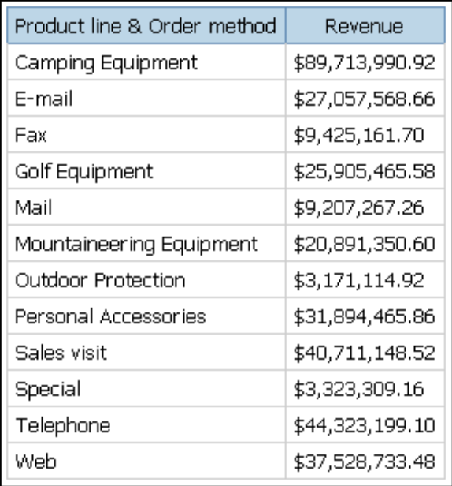

Lab 23 - Create a Crosstab Report that Shows Empty Rows

- Objective :

You are a report author at the Great Outdoors Company, which sells sporting equipment. You are
requested to create a crosstab report that shows the total revenue per year for each product line,
broken down by order method. By default, if no revenue was produced for a particular product
line in a specific year, no row appears in the crosstab for that product line and year. You override
the dimension information of the crosstab so that empty rows appear in the report.

- Steps

- In the Cognos Connection Welcome page, click the Public Folders link.
- Click the GO Sales and Retailers link, and then click the Report Studio link at the upper-right corner of the page.
- In the Welcome dialog box, click Create a new report or template.
- In the New dialog box, click Crosstab and click OK.
- In the Insertable Objects pane, on the source tab, drag the following data items to the crosstab:
  - Product line as rows
  - Order year as nested rows
  - Order method as columns
  - Revenue as the measure
Tip: You can find these items in the Products and Orders folders.
- Right-click the crosstab and click Go to Query.
- In the Properties pane, click the Override Dimension Info property and click Yes.
The Dimension Info tab appears at the bottom of the work area.
- Click the Dimension Info tab.
- In the Insertable Objects pane, on the source tab, drag the following items to the Dimensions pane:
  - Product line
  - Order year
Product line and Order year become separate dimensions in the query.
- Pause the pointer over the page explorer button and click Page1.
- Click Order year.
- In the Properties pane, double-click the Sort property.
- In the Data Items box, drag Order year to the Sort List box and click OK.
- Run the report.
All order years appear for all product lines, even if no revenue was produced.
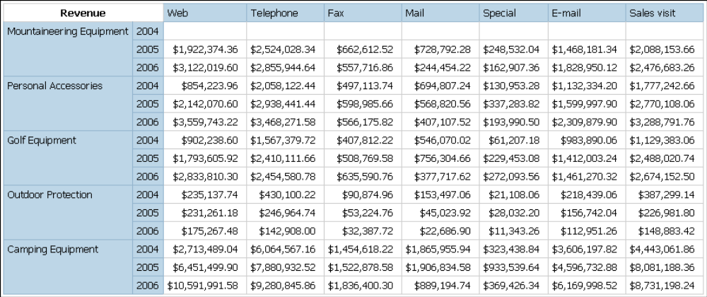

Lab 24 - Example - Burst a Report

- Objective

You are a report author at The Great Outdoors Company, which sells sporting equipment. You
are requested to create a report that lists product sales for each sales representative. The report is
to be emailed to each sales representative, but they do not need to see data for everyone, only the
data that pertains to them. You create a list report that you burst to each sales representative.

- Steps

- In the Cognos Connection Welcome page, click the Public Folders link.
- Click the GO Sales and Retailers link, and then click the Report Studio link at the upper right corner of the page.
- In the Welcome dialog box, click Create a new report or template.
- In the New dialog box, click List and click OK.
- In the Insertable Objects pane, on the source tab, add the following data items to the list by double-clicking them:
  - Staff name
  - Product line
  - Product type
  - Product name
  - Quantity
  - Revenue
Tip: You can find these data items in the Sales reps, Products, and Orders folders.
- Group the Staff name, Product line, and Product type columns.
- Click the Staff name column, and then click the create header button.
Staff name appears as a header in the list. You no longer need to keep the data item as a list column.
- In the list, click Staff name and click the delete button.
- Click Revenue, click the aggregate button, and click Total.
- Pause the pointer over the query explorer button and click Query1.
- In the Insertable Objects pane, on the source tab, drag Email from the Sales reps folder to the Data Items pane.
- From the File menu, click Burst Options.
- Select the Make report available for bursting check box.
- Under Burst Groups, in the Query box, click Query1.
- In the Label box, click Staff name.
- Click the edit button.
- In the Data Items box, drag Staff name to the Groups folder and click OK.
- Under Burst Recipient, in the Query box, click Query1.
- In the Item box, click Email.
- In the Type box, click Email addresses.
- Click OK.
- Save the report.
- Locate the report in Cognos Connection.
- Under Actions, click Run with options.
- Click the Advanced options link.
- Select the Burst the report check box.
- Select the Send the report by email check box.
- Click Run and then click OK.
When sales representatives access their email accounts, they will see a report with only the data that is meant for them.

Lab 25 - Create a Conditional Report

- Steps

- In the Cognos Connection Welcome page, click the Public Folders link.
- Click the GO Sales and Retailers link, and then click the Report Studio link at the upper-right corner of the page.
- In the Welcome dialog box, click Create a new report or template.
- In the New dialog box, click List and click OK.
- In the Insertable Objects pane, on the source tab, add the following data items to the list by double-clicking them:
  - Order date
  - Order number
  - Product name
  - Description
  - Quantity
  - Unit sale price
  - Revenue
Tip: You can find these data items in the Products and Orders folders.
- Click Order Date and click the section button.
- Group the Order Number column by selecting the column and clicking the group button.
- Click Revenue, click the aggregate button, and click Total.
- Change the title of the report to New Orders.
- Pause the pointer over the page explorer button and select Prompt Pages.
- Create a new prompt page by double-clicking Pages in the Insertable Objects pane.
- Double-click the new prompt page.
- In the Insertable Objects pane, on the toolbox tab, double-click Text Item and type the following text:
Enter the start date, and select if descriptions will be shown.
- Insert a 2 × 2 table into the prompt page using the insert table toolbar button, and moving the pointer until four squares are highlighted in a 2 × 2 pattern.
- In the Insertable Objects pane, on the toolbox tab, drag Text Item into the upper-left cell and type the following text:
Starting Date.
- In the Insertable Objects pane, drag a Text Item into the lower-left cell, and type the following text:
Show Descriptions.
- In the Insertable Objects pane, drag a Date Prompt into the upper-right cell.
- When prompted with the Prompt Wizard, Choose a Parameter window, select Create a new
parameter and type p_Date in the space provided, then click Next.
- When prompted in the Create Filter window, select Create a parameterized filter with the
following entries:
  - For Package item, click the ellipsis (...) button and click
[gosales_goretailers].[Orders].[Order date].
  - For Operator, click >.
- Click Finish.
- In the Insertable Objects pane, drag a Value Prompt into the lower-right cell.
- When prompted with the Prompt Wizard, Choose a Parameter window, select Create a new
parameter and type p_ShowDescn in the space provided, and then click Finish.
- Select the Value Prompt, and in the Properties pane, double-click Static Choices.
- Click Variable, click <New boolean variable>, and when prompted, type the name showDesc.
- Click the add button.
- In the Edit dialog box, type Yes in both the Use and Display boxes.
- Click the add button.
- In the Edit dialog box, type No in both the Use and Display boxes.
- Click OK.
- Pause the pointer over the condition explorer button and click Variables.
- Click the showDesc variable, and in the Properties pane, double-click Report Expression.
- In the Report Expression dialog box, type the following in the Expression Definition window:
ParamDisplayValue("p_ShowDesc") = 'Yes'
- Click OK.
- Pause the pointer over the page explorer button and click the report page.
- Click the Descriptions column.
- In the Properties pane, select the list column by clicking the select ancestor button and selecting List Column from the context menu.
- In the Properties pane, double-click the Render Variable parameter and select the showDesc boolean variable you created in steps 24 to 33.
- Click Run.
The report will prompt you for a date, and will then provide orders that occur after the date you entered. The report will also ask if the Descriptions column is to be shown, and the column will be rendered only if you choose Yes to this selection.

Lab 26 - Create a Drill-through Report

- Objective

You are a report author at The Great Outdoors Company, which sells sporting equipment. You
are requested to create a report that lists the product sales for each product line, and allows the
reader to drill-through from the sales report to view the product details for any item selected.
You will create two reports, one that contains the details for the item, and another that lists the
product sales.

- Steps

- In the Cognos Connection Welcome page, click the Report Studio link.
- Select the package GO Sales and Retailers.
- In the Welcome dialog box, click Create a new report or template.
- In the New dialog box, click List and click OK.
- In the Insertable Objects pane, on the source tab, add the following data items to the list by double-clicking them:
  - Product line
  - Product type
  - Product name
  - Description
  - Introduction date
  - Product image
Tip: You can find these data items in the Products folder.
- Click the filters button.
- Click the add button, and type the following in the Expression Definition window:
[gosales_goretailers].[Products].[Product name]=?p_PL?
- Click OK.
- Change the title of the report to Product Details.
- Save the report as Product Details.
- From the File menu, click New to create a new report.
- In the New dialog box, click List and click OK.
- In the Insertable Objects pane, on the source tab, add the following data items to the list by double-clicking them:
  - Product line
  - Product type
  - Product name
  - Quantity
  - Revenue
Tip: You can find these data items in the Products and Orders folders.
- Group the Product line and Product type columns.
- Click the Product Line column, and then click the create header button.
Product Line appears as a header in the list. You no longer need to keep the data item as a list column.
- In the list, click Product Line and click the delete button.
- Click Revenue, click the aggregate button, and click Total.
- From the Data menu, click Drill Behavior.
- On the Basic tab, in the Report Drill Capabilities, select the Allow drill through from a package check box.
- Click OK.
- Right-click the Product Name column and select Drill Throughs.
- Click the new drill through button.
- Under Report, click the ellipsis (...) button and select the Product Details report you created previously.
- Click Action and click Run the Report.
- Click Format and click HTML.
- Click the edit button.
- For the item p_PN, under Method, select Pass data item value, and select Product name for the Value.
- Click OK twice.
- Change the title of the report to Product Revenue.
- Save the report as Product Revenue.
- Click Run.
When the report is rendered, the list will show the product names as clickable links. When a
product is clicked, the second report will be run for that product.

Lab 27 - Create a Drill-up/Drill-down Report

- Objective

You are a report author at The Great Outdoors Company, which sells sporting equipment. You
are requested to create a report that lists product sales for each product line. The user must be able
to drill-down to retrieve data on the same criteria with a more detailed scope.

- Steps

- In the Cognos Connection Welcome page, click the Report Studio link.
- Select the package Great_Outdoors_Company.mdc.
- In the Welcome dialog box, click Create a new report or template.
- In the New dialog box, click Crosstab and click OK.
- In the Insertable Objects pane, on the source tab, add Year followed by Years to the columns section.
- Add General Manager followed by Product Line to the rows section.
- Insert Products as a total row in the crosstab.
- Insert Revenue as the measure for the report.
- From the Data menu, click Drill Behavior.
- On the Basic tab, select the Allow drill up and down check box.
- Click OK.
- Change the title of the report to Sales Report: Product Revenue by Period.
- Save the report.
- Run the report.
When the report is rendered, the list shows the sales manager, the product lines, and even the years as links. When you right-click a link, a context menu allows you to drill-up or drill-down to run the report from a higher or lower level scope of that dimension. Notice how the Years and Products total columns are also updated.

Lab 28 - Try It Yourself - Create a List Report

- Objective

Use list reports to show detailed information from your database, such as product lists and
customer lists.
In this topic, you learn how to create a list report that shows revenue for each product for the last
quarter of 2002.
It should take 15 to 20 minutes to complete this topic, and your report will look like this.

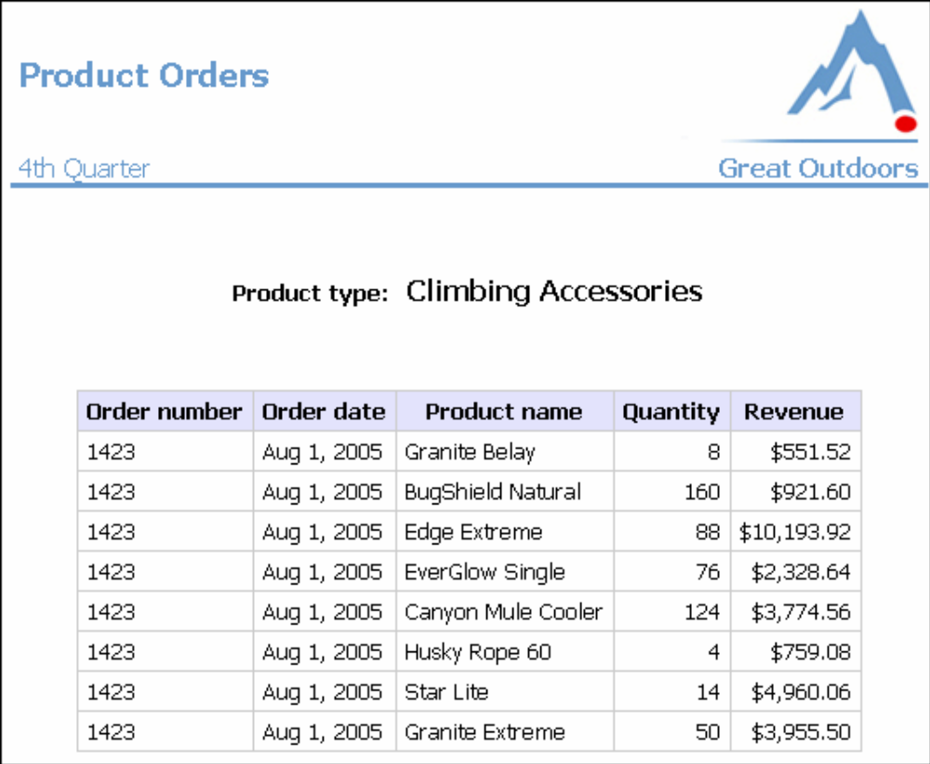

- Steps

- Create a new list report that uses the sample package named GO Sales and Retailers and the sample template named GO-list.
- Add the following data items to the report:
  - Order number (in Orders)
  - Order date (in Orders)
  - Product type (in Products)
  - Product name (in Products)
  - Quantity (in Orders)
Tip: Use the Source tab in the Insertable Objects pane.
- Create this query calculation named Revenue:
[gosales_goretailers].[Orders].[Unit price] * Quantity
Tip: Use the Toolbox tab in the Insertable Objects pane.
- Group the Product type column to make the report easier to read. Then group the Order date column.
- Make the Product type column appear as a section header in the report.
- Bold Product type in the body of the report.
- Remove the Product type column title without removing Product type from the body of the report.
- Add a total to the Revenue column to view total revenue for each product type.
- Create this tabular filter to view revenue for the last quarter of 2002.
[Order date] between 2002-10-01 and 2002-12-31
- Change the Data Format property for the Order date column to be date only, not date and time.
- Change the title text placeholder to this text:
Product Orders
- Add the following text to the bottom cell, replacing the date object:
4th Quarter
- Format the text as Tahoma, 11 pt, and apply the Web-safe color #6699CC.
- Run the report to view what it will look like for your users.

Lab 29 - Try It Yourself - Create a Crosstab

- Objective

Use crosstab reports to compare information that uses one or more criteria. The values at the
intersection points of rows and columns show summarized information.
In this topic, you learn how to create a crosstab that shows the cost of goods sold for each product
line and product type by quarter.
It should take 15 to 20 minutes to complete this topic, and your report will look like this.

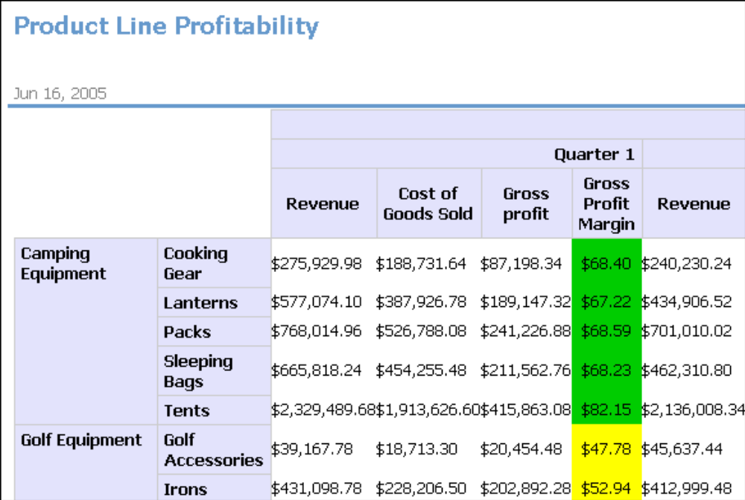

- Steps

- Create a new crosstab that uses the sample package named GO Sales and Retailers and the sample template named GO-crosstab.
- Add the following data items to the report:
  - Order year (in Orders) in the columns
  - Product line (in Products) in the rows
  - Revenue (in Orders) as the first measure
  - Gross profit (in Orders) as the second measure
Tip: Use the Source tab in the Insertable Objects pane.
- Nest Product type (in Products) after Product line in the rows.
- Nest Order month (in Orders) under Order year in the columns.
- Change the Expression property for Order month to:
mod([gosales_goretailers].[Orders].[Order month],4)+1
Tip: Use the Toolbox tab in the Insertable Objects pane.
- Create this query calculation named Cost of Goods Sold:
[Revenue]-[Gross Profit]
- Change the Data Format property for Revenue, Gross profit, and Cost of Goods Sold to currency.
- Change the blue text placeholder to this text:
Profitability by Product Line
- Run the report to view what it will look like for your users.

Lab 30 - Try It Yourself - Create Charts

- Objective

Use charts to reveal trends and relationships that are not evident in tabular reports.
Report Studio gives you flexibility in how you organize data in charts.
In this topic, you learn how to create charts that show different information.
It should take 15 to 20 minutes to complete this topic.

Basic Charting
Let's take a look at the basic chart interface.

- Steps to Create a Basic Column Chart

- Open Report Studio with the GO Sales and Retailers package.
- Create a new Chart report.
- Click OK to open the default column chart.

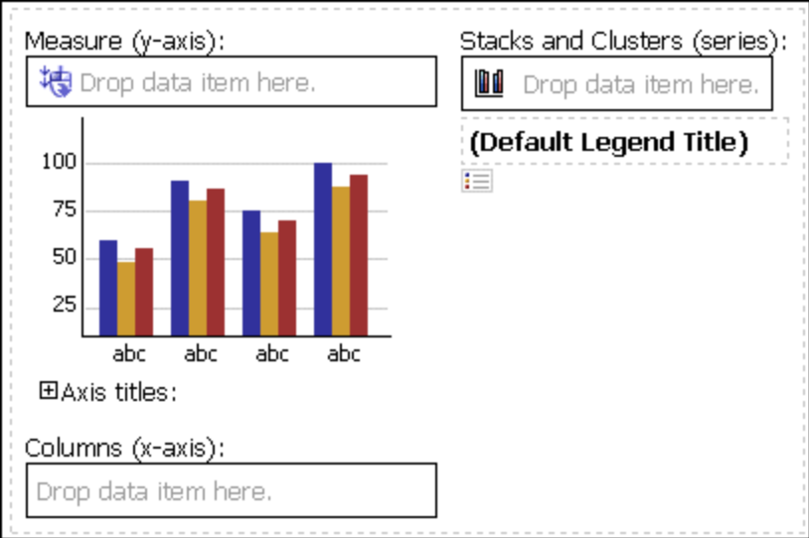

You can click on the white space around the chart to select the whole chart, or you can click on an individual item, such as an axis icon or chart type icon, to find a given chart property.
The Series drop zone defines the items that appear in the legend. This is the legend edge. The Category (x-axis) drop zone defines the ordinal edge.
Let's chart some GO Sales and Retailers data.

- Steps to Add Data to a Chart

- Drag the following items to the chart:
  - Revenue (in Orders) to the Measure drop zone
  - Product line (in Products) to the Category (x-axis) drop zone
Tip: Use the Source tab in the Insertable Objects pane.
Column, bar, line, area, and clustered charts are based on the same combination chart for flexibility in charting.
- Run the report to see your chart.

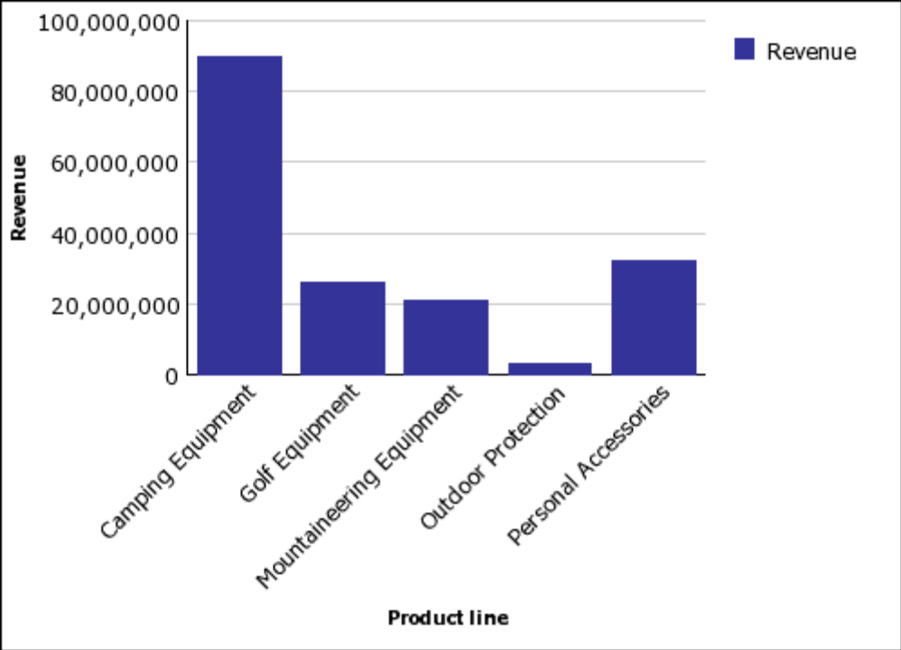

Return to Report Studio.

- Steps to Show Values in a Chart

We want to show the revenue value on each column in the chart.
- Click the bar icon in the Series drop zone.
- In the Properties pane, under Chart Labels, change the Values property to Show.
- Run the report to see your chart.
You can customize the font properties for the values shown in the chart, independent of the axis labels.
- From the Structure menu, clear Lock Page Objects to unlock the chart objects.
- Select the chart body by clicking between the axis.
- In the Properties pane, increase the font size and change the foreground color to red.
- Run the report to see your chart.
This makes the values easier to see. After we add more data, showing the values clutters the chart, so we will remove them from view again.
- Return to Report Studio.
- Click the bar icon in the Series drop zone.
- In the Properties pane, under Chart Labels, change the Values property to Hide.
Let's group this chart based on Order Method.

- Steps to Group Data in a Chart

- Drag Order method (in Orders) to the Series drop zone.
- Run the report to see your chart.

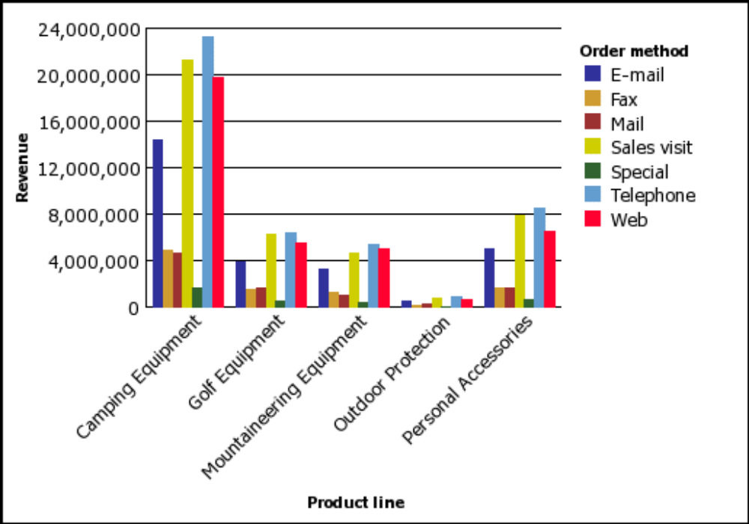

- Return to Report Studio.
Let's see what other kind of charts we can make with this data.

- Steps to Change the Chart Configuration

- Click the Order method legend item icon.

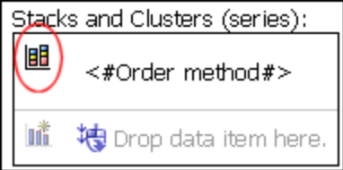

There are many properties to let you customize how the columns are shown.
- In the Properties pane, set the Grouping Type property to Stacked.
- Run the report to see your chart

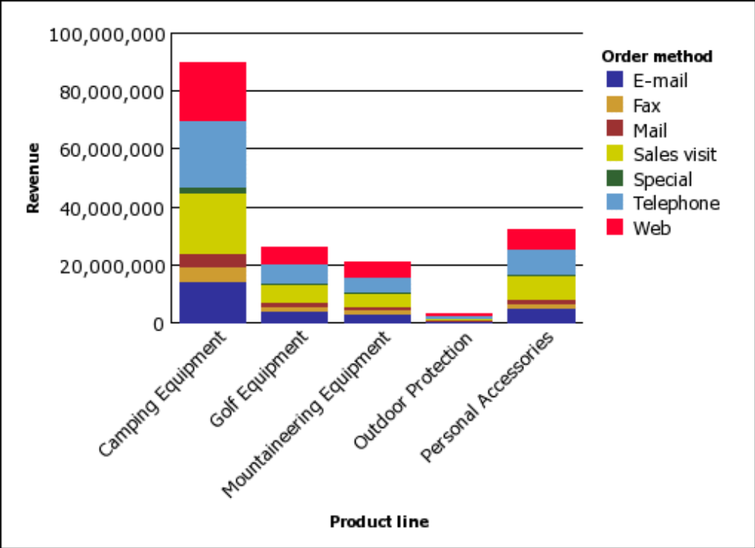

- Return to Report Studio.
You can also use the properties in the Properties pane to show the data as a 100% stacked column chart, show or hide borders, and so on.
Let's add some more data to this chart.

- Steps to Combine Sets of Data in Charts

- Add Order year (in Orders) to the Series drop zone.
This is how you union together the Order method and Order year items on the legend edge:

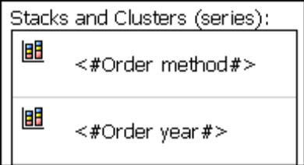

- Run the report to see your chart.
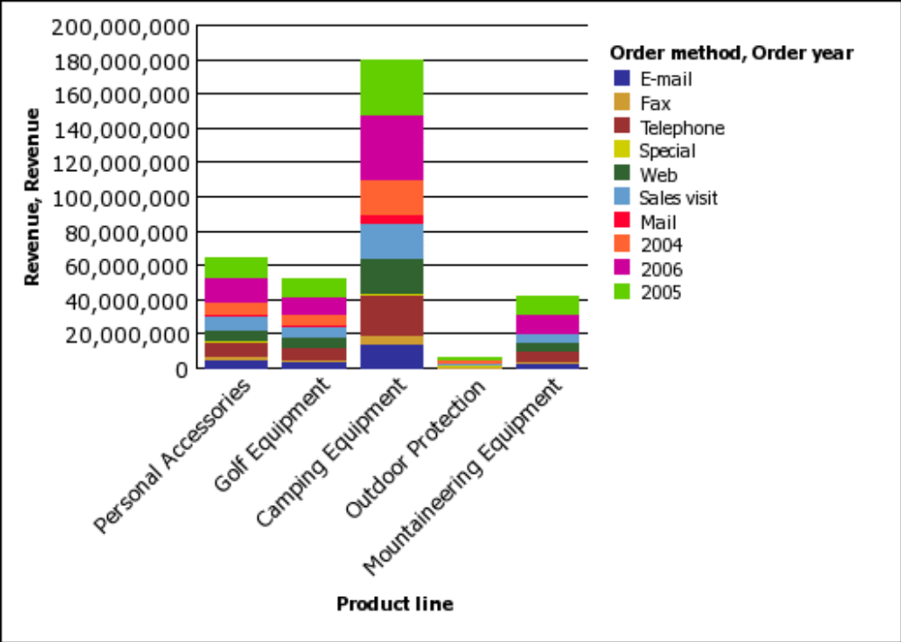

Report Studio places another set of data values on the stack.
- Return to Report Studio.
- Click the Order year legend item icon.
- In the Properties pane, set the Grouping Type property to Clustered.
- Run the report to see your chart.

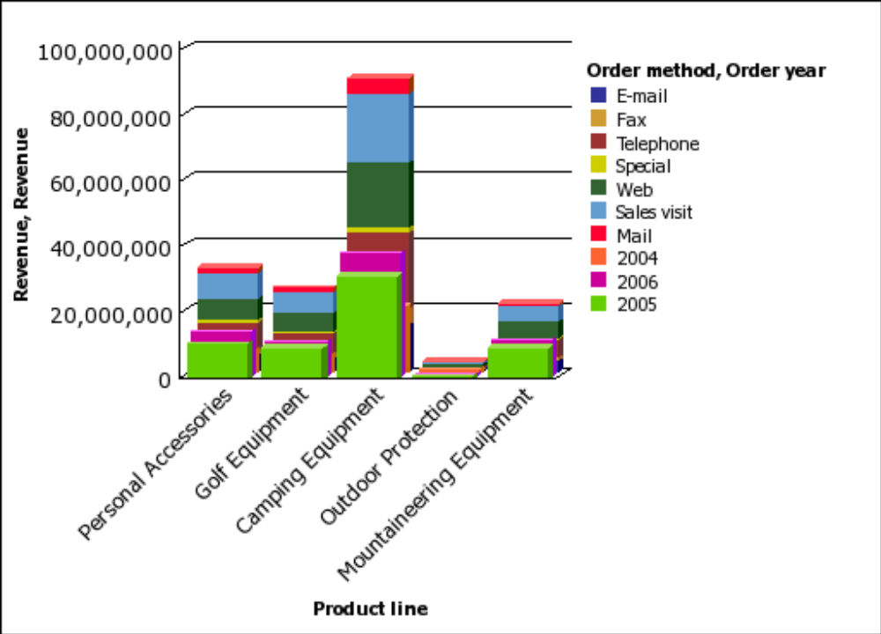

You can combine stacked and unstacked charts.
- Return to Report Studio.
- Select Order year.
- Set the Chart Type property to Line.
- Run the report to see your chart.
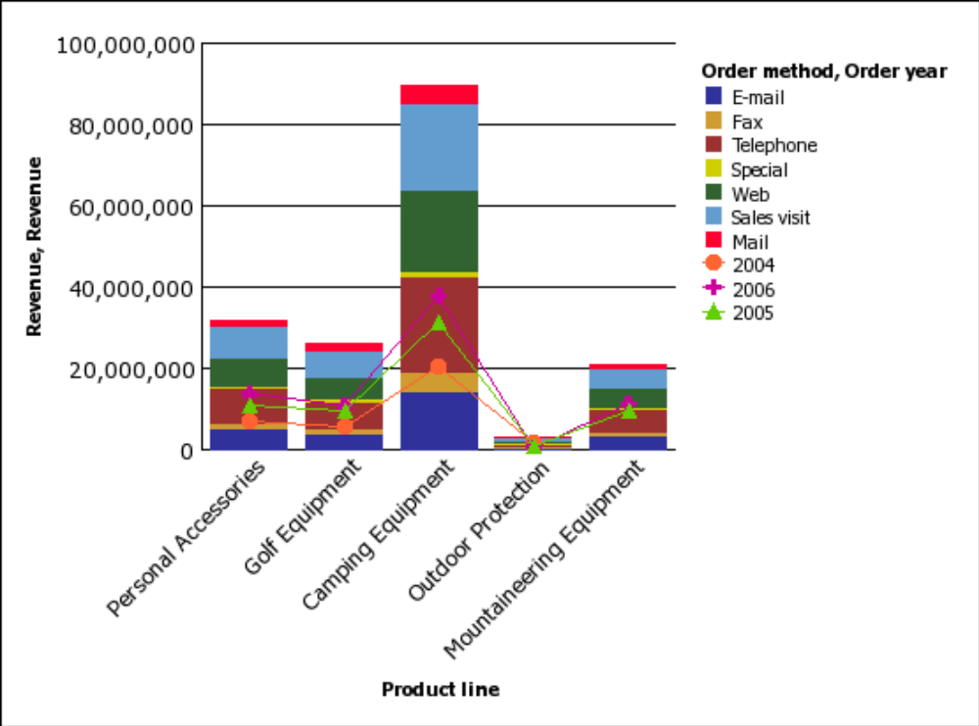

You can combine line and stacked charts. Let’s improve the presentation of the Order year values by showing them on their own y-axis.

- Steps to Change the Chart Presentation

- Return to Report Studio.
- Select Order year.
- Set the Axis Assignment property to Y Axis 2.
The chart image now shows two y-axes. There are two ways to view this second y-axis.
- Select the chart background, and set the Y2 Axis Position property to bipolar.
- Run the report to see your chart.
The line chart appears under the stacked column chart.
- Return to Report Studio.
- Select the chart background, and set the Y2 Axis Position property to dual.
- Run the report to see your chart.
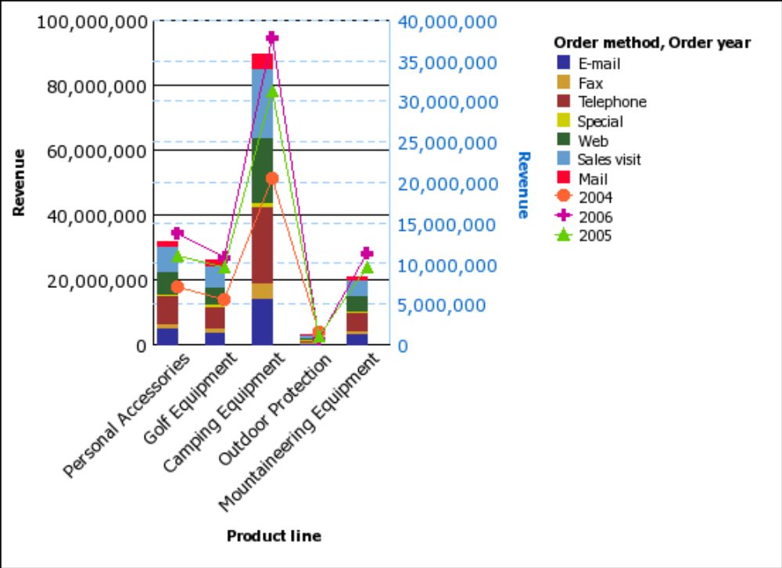

Now the chart is too narrow. We also prefer points instead of lines.
- Return to Report Studio.
- Select Order year and, in the Properties pane, change the Line property from Yes to No.
You can also use the Properties pane to resize the points, restyle the lines, and so on.
- Select the chart background, set the Size & Overflow property Width to 1000 px, and click
OK.
Run the report to see your chart.

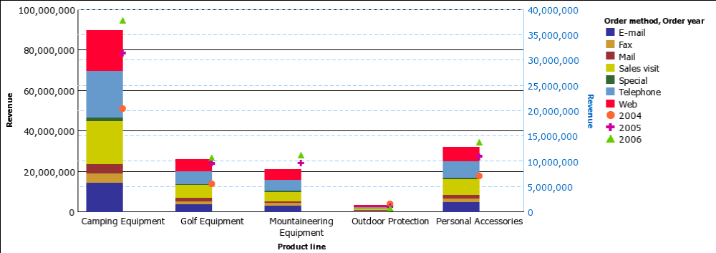

- Return to Report Studio.
There is another way to show the second axis.
- Set the Y Axis 2 property to bi-polar.
You can pivot a chart like a crosstab.
- Click the swap rows and columns button on the toolbar.
There are now two ordinal edge entries: Order method and Order year.

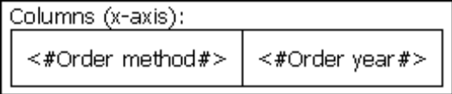

You can union and nest data items on both edges equally. There is an additional drop zone on the legend edge because multiple legend entries are more common in charting than multiple ordinal edge entries.
- Run the report to see your chart.

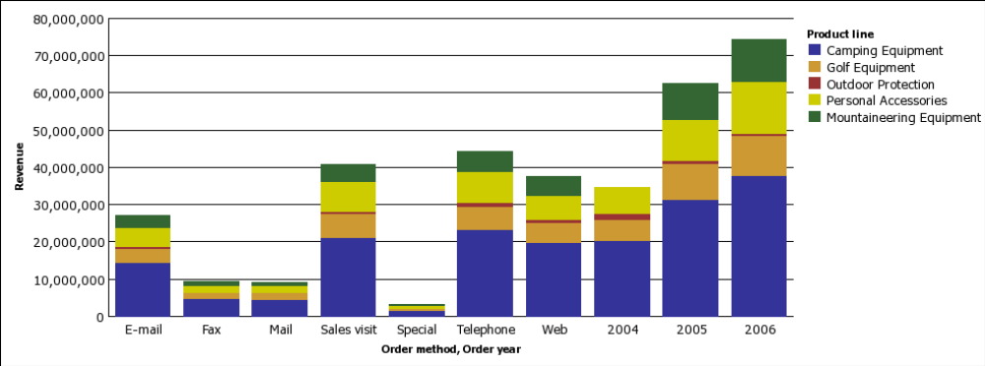

- Return to Report Studio.
You can view this as a horizontal bar chart.
- Select the chart and set the Chart Orientation property to Horizontal.
- In the Size & Overflow property, delete the Width value.
- Run the report to see your chart.
You nest data to make charts even more flexible. For example, you can nest Order Year within Order Method to show the trend for each order method.
Steps to Nest Data
- Return to Report Studio.
- Drag Order year below Order method as shown below.
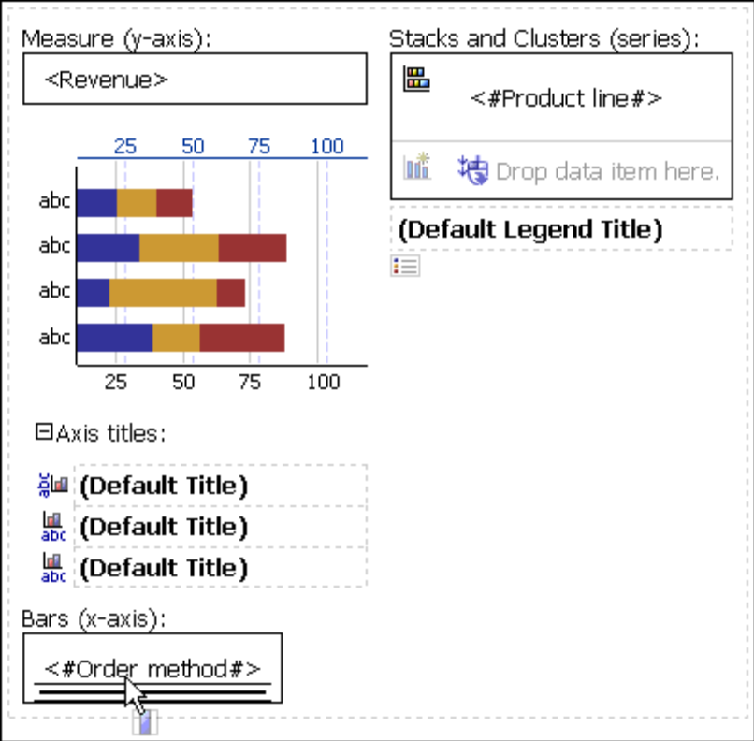

- Click Order year in the Category (y-axis) drop zone, and from the Data menu, click Sort
Ascending.
There are several drop zones in this area. They allow you to nest and union data as you can in a crosstab.
- Run the report to see your chart.
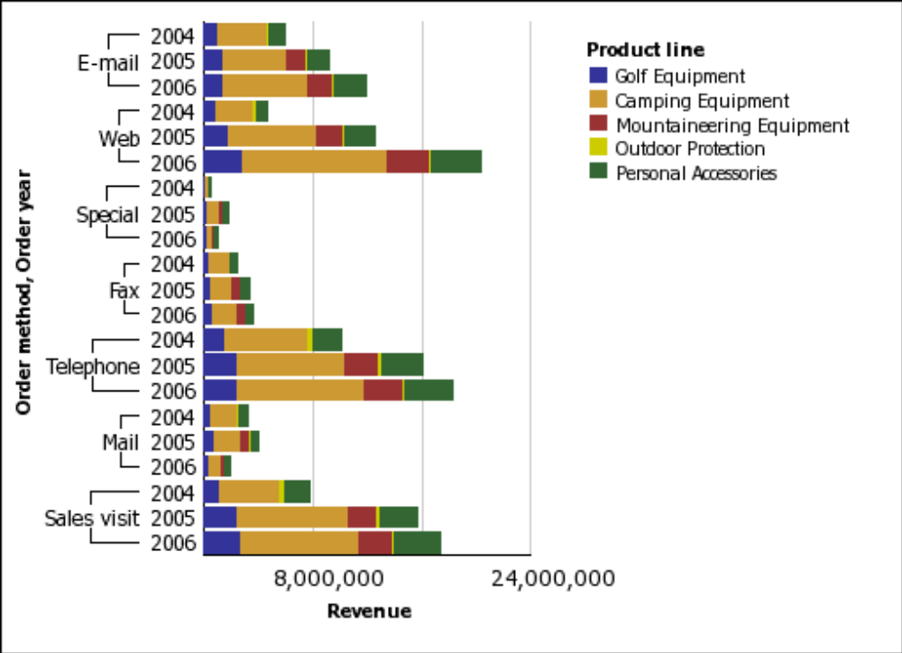

You can convert one chart type into another. We will start with a progressive column chart to show revenue contribution by product line.

- Steps to Convert a Chart

- Create a new chart.
- In the Chart group pane, click Progressive.
- In the Chart type pane, click Progressive Column.
- Click OK.
- Drag Revenue (in Orders) to the Measure (y-axis) drop zone.
- Drag Product line (in Products) to the Category (x-axis) drop zone.
- Run the report to see your chart.
- Return to Report Studio.
- Right-click the chart, and from the right-click menu, click Convert Chart.
- Click OK to open the default column chart.
- In the Chart Conversion Loss dialog box, click OK.
Up to now, we have used only a single measure on the chart. Now we will use two measures to compare revenue versus planned revenue for each product line.
- Drag Revenue from the Measure (y-axis) drop zone to the Series drop zone.
- In the Properties pane, ensure that the Chart Type property is set to Bar.
- Drag Planned Revenue (in Orders) to the Series drop zone, under Revenue.
- Select Planned Revenue and, in the Properties pane, set the Chart Type property to Line.
- Change the Line property from Yes to No.
- Run the report to see your chart.
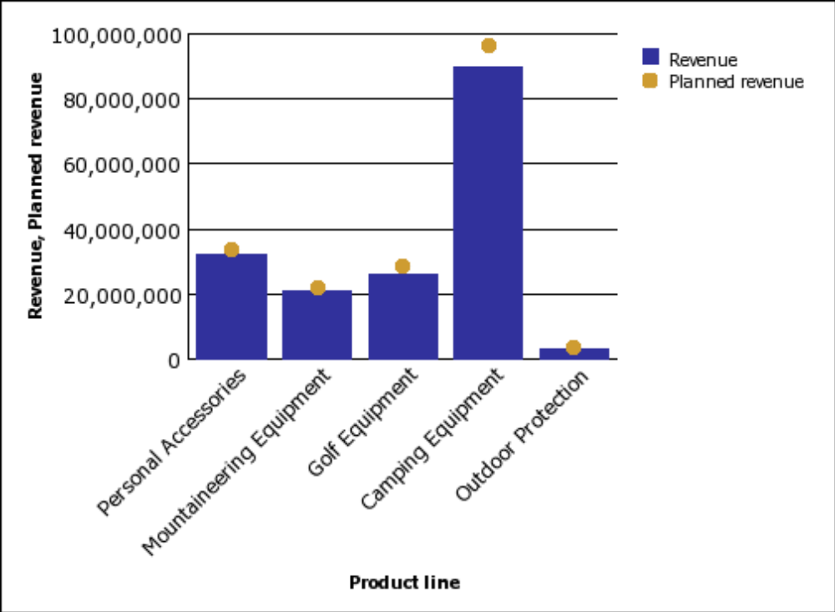

- Return to Report Studio.
You can also show Planned revenue as a radar chart.
- Right-click the chart, and from the right-click menu, click Convert Chart.
- In the Convert Chart dialog box, click the Radar, Polar chart group and the Radar with
Markers chart type. Click OK.
- In the Chart Conversion Loss dialog box, click OK.
- Run the report to see your chart.

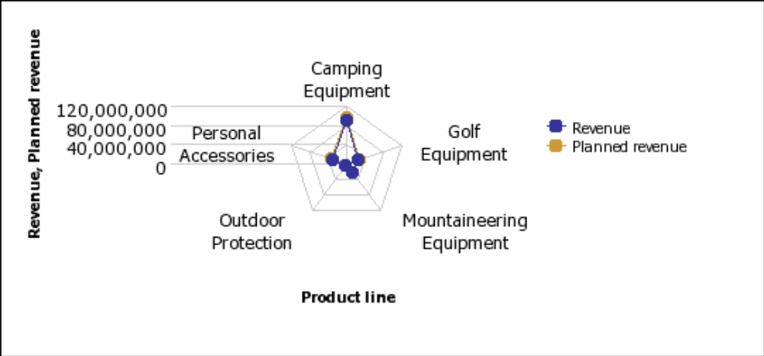

It is difficult to distinguish Revenue from Planned revenue in this chart type. Another chart you can use to compare revenue and planned revenue is a metrics range chart.

- Steps to Create a Metrics Range Chart

- In Cognos Connection, go to the GO Sales and Retailers package.
- Click the Report Studio link.
- Report Studio starts.
- From the File menu, click New.
- Click Chart and click OK.
- In the Chart group pane, click Metrics Range.
- In the Chart type pane, click Column Chart with Range Indicators.
- Click OK.
- Drag the following items to the chart:
  - Revenue (in Orders) to the Actual (y-axis) drop zone.
  - Planned revenue (in Orders) to the Target (marker) drop zone.
  - Order year (in Orders) to the Category (y-axis) drop zone
- From the Insertable Objects pane, on the toolbox tab, drag a query calculation to the Tolerance (marker) drop zone.
- In the Create Calculation dialog box, type Tolerance
- Click OK.
- In the Expression Definition box, type the expression:
[Planned revenue] * 0.1
- Click OK.
- Click run on the toolbar, and view the report.

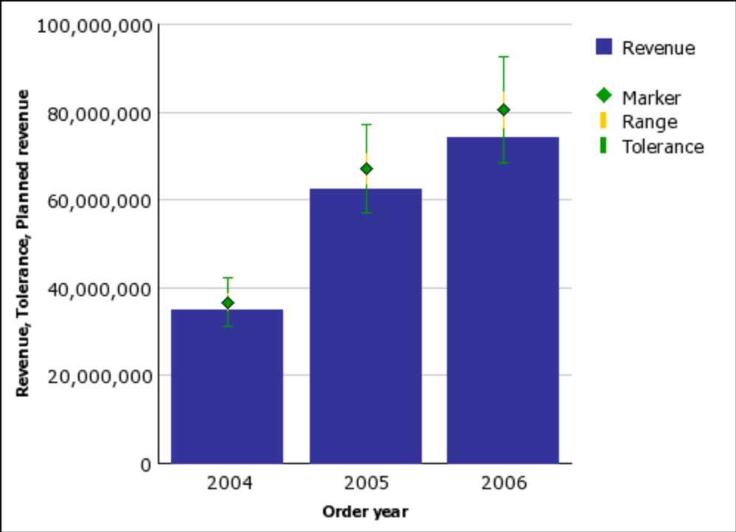

Lab 31 - Try It Yourself - Create Map Reports

- Objective

Use maps to represent data that can be displayed spatially. Cognos 8 includes maps that you can
link to data in your data source. Maps can be edited and additional maps can be added by using
Map Manager.

Show the Distribution of Revenue by Country
In this exercise, you use a map of the world to show revenue by country.

- Steps to Begin a Map

- Open Report Studio with the GO Sales and Retailers package.
- Create a new Map report.
- In the Region Layers box, click World Countries.
- In the Point Layers box, click None.
- Click OK.
Tip: You can return to the Choose Map dialog box at any time by double-clicking the map object.

- Steps to Define the Region Layer

- In the Insertable Objects pane, expand Orders.
- Drag Revenue to the Color drop zone.
- In the Insertable Objects pane, expand Countries.
- Drag Country to the Location drop zone.
- Run the report.
An error message indicates that the country names for Korea and Taiwan in the data source differ from those in the map file. There are two ways to avoid this error. You can set the Ignore Data with no Features property to Yes, or use the Dictionary property to match the map file to the data source. In this exercise you will match the data values to names in the map file.
To see a list of countries in the data source, you can run a list report.

- Steps to Match Data Values to Names in the Map File

- Select the map body.
The Title Bar of the Properties pane now shows the word Map.
- In the General section of the Properties pane, click Dictionary, then click the ellipses points
(...).
- Click the new button.
- In the Dictionary Entry dialog box, click Search.
- In the Search string box, type Korea
- In the Search map layer box, click World Countries, and click Search.
- In the Matching features box, click Korea Democratic People’s Republic of and click OK.
- In the Alias box, type Korea and click OK.
- Use the same method to create the alias Taiwan for Taiwan, Province of China.
- The Dictionary dialog box now shows aliases for Taiwan and Korea.
- Save the map report.
- Run the report.

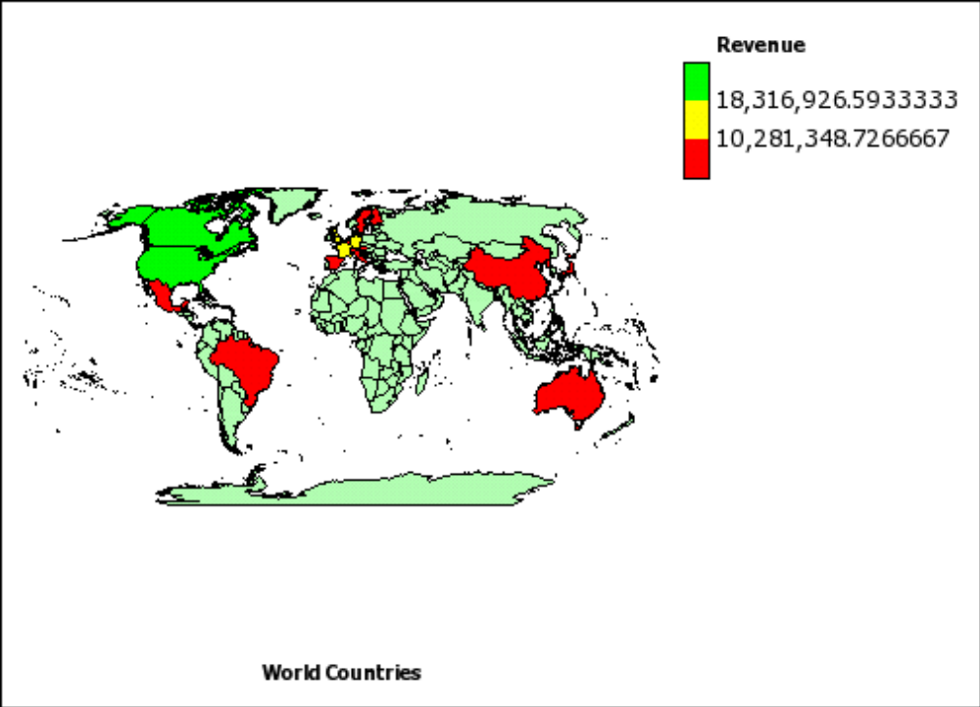

- Steps to Format the Numbers in the Legend

- In the region layer, click the Revenue measure in the color drop zone.
- In the Data section of the Properties pane, click Data Format, and then click the ellipsis points (...).
- In the Format Type box, select Currency.
- For the Currency property, select $ (USD) - United States.
- For the No. of Decimal Places property, select 0 and click OK.
- Run the report.

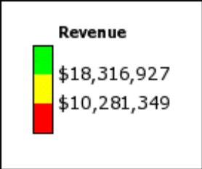

- Steps to Add Another Color to the Map

- In the Report, click Region Layer.
- In the Chart Annotations section of the Properties pane, click Palette, and then click the
ellipses points (...).
- Click the new button, and click Color.
A new color is added to the list of colors.
- With the new color selected, click Color in the right pane of the dialog box, and select a color.
Four colors are now defined.
- Change the percentage boundaries for the colors to 25, 50, and 75.
- Click OK.
- Run the Report.
The colors on the map now indicate four levels of revenue.

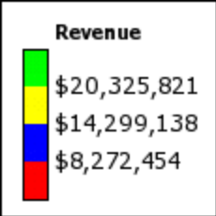

Show Revenue and Margins for Cities in the United States

In this exercise you use a map of the United States to show revenue and margins for outlets by
using points for cities.

- Steps to Begin the Map

- Open Report Studio with the GO Sales and Retailers package.
- Create a new Map report.
- In the Choose Map dialog box, in the Maps pane, expand Americas and click United States Inset.
- In the Region Layers box, click USA.
- In the Point Layers box, click USA Major Cities.
- Click OK.
Tip: You can return to the Choose Map dialog box at any time by double-clicking the map body.

- Steps to Set the Point Layer

- In the Insertable Objects pane, expand Orders.
- Drag Margin to the Color drop zone in the Point Layer.
- Drag Revenue to the Size drop zone in the Point Layer.
- In the Insertable Objects pane, expand Sales branch address.
- Drag City to the Location drop zone in the Point Layer.
- Click the map object.
- In the Properties pane, click Ignore Data with no Features and change the property to Yes.
This specifies that the report will run even if there is not a match in the map file for every data value retrieved from the data source.
- Run the report.
The points are located at cities with sales branches. The size of the point shows the level of
revenue and the color of the point shows the margin for each sales location.

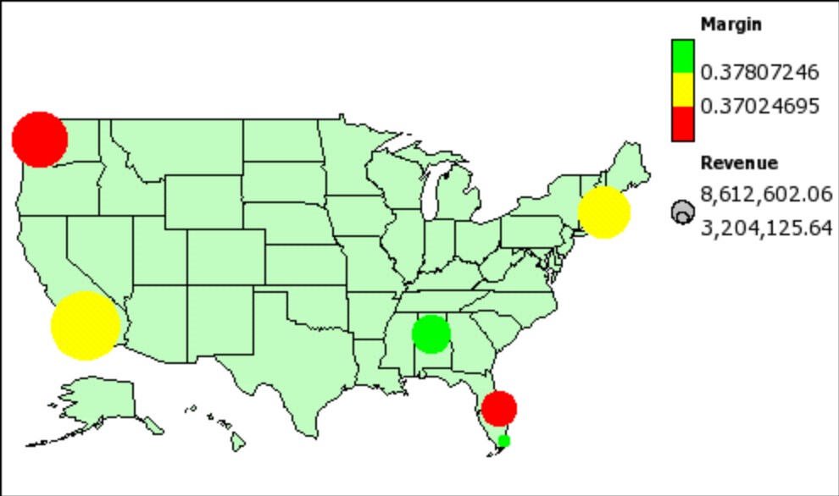

- Steps to Change the Size of the Points

- In the point layer, click Revenue in the Size drop zone.
- In the General section of the Properties pane, click Minimum Size, and select 2pt.
- Click Maximum Size, and select 10pt.
- Run the report.
The points on the map are now smaller.

Lab 32 - Try It Yourself - Add Prompts

- Objective

Use prompts to filter data by using the criteria entered when the report is run.
In this topic, you learn how to create cascading prompts for an existing report. Your users will
have the choice of filtering data in the line chart or viewing all the data.
It should take 10 to 15 minutes to complete this topic, and your prompt page will look like this.

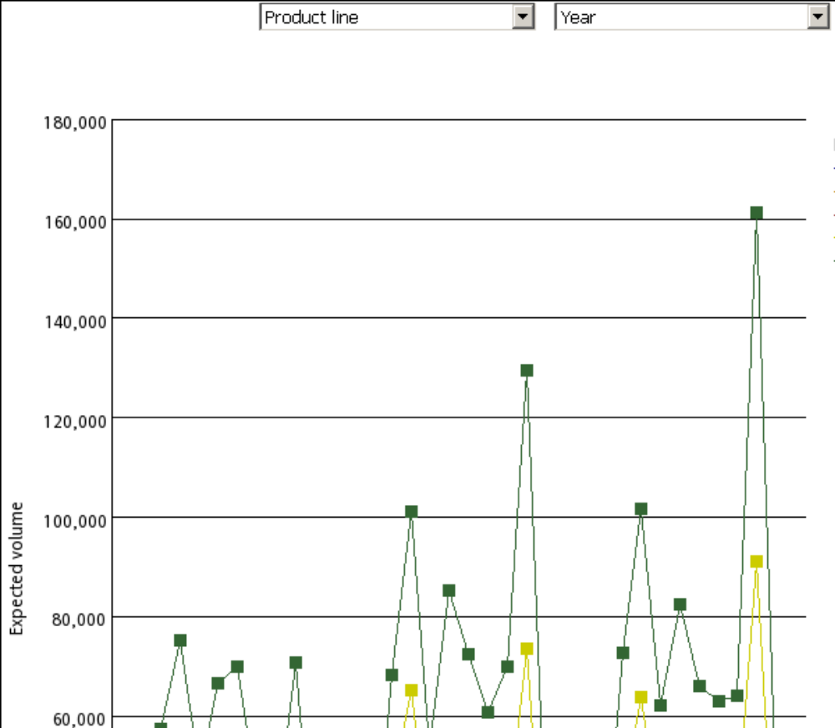

- Steps

- Open the sample report named Product Line by Year.
- Add a value prompt to the report that uses Product line code for the package item. Use Product line as the values to display. This is an optional filter.
Tip: Use the Toolbox tab in the Insertable Objects pane.
- Add a value prompt to the report that uses Year for the package item and the values to
display. This is an optional filter.
- Ensure the Required property for both prompts to No.
- Change the title text placeholder to this text:
Product Line by Year
Run the report to view what it will look like for your users

Lab 33 - Try It Yourself - Create a Multiple-Page Report

- Objective

Add pages to a new or existing report that contain different content to create a multiple-page
report.
In this topic, you learn how to create a multiple-page report that shows several sales performance
reports.
It should take 15 to 20 minutes to complete this topic, and your report pages will look like this.

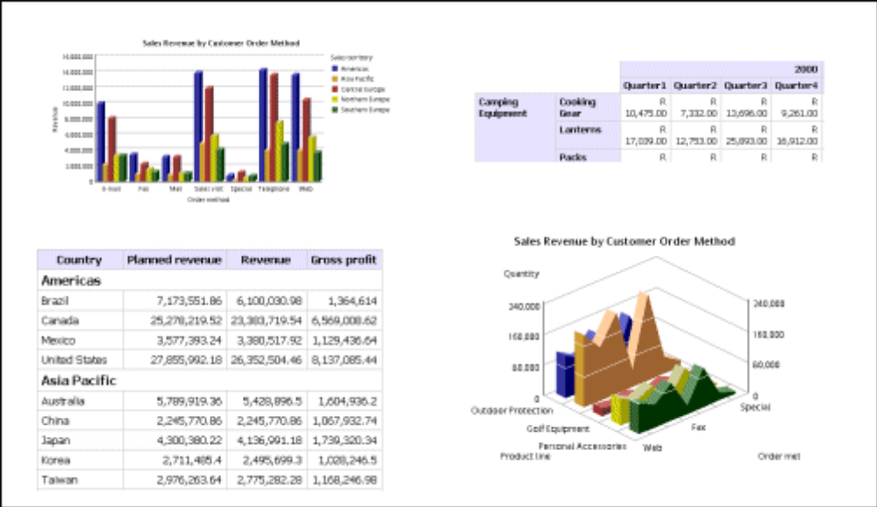

- Steps

- Open the sample report named Global Sales (1). This sample contains several reports.
- Add a page.
- Add a 3-D column chart to the new page as a new query.
- Add these data items to the chart:
  - Revenue (in Orders) as the axis measure
  - Order method (in Orders) as the category
  - Sales territory (in Countries) as the series
Tip: Use the Source tab in the Insertable Objects pane.
- Add a list report to the page as a new query.
- Add these data items to the list report:
  - Sales territory (in Countries)
  - Country (in Countries)
  - Planned revenue (in Orders)
  - Revenue (in Orders)
  - Gross profit (in Orders)
- Group the Sales territory column to make the report easier to read. Then group the Country column.
- Make the Sales territory column appear as a list header in the report.
- Bold Sales territory in the body of the report.
- Remove the Sales territory column title without removing Sales territory from the body of the report.
- Change the blue text placeholder to this text:
Performance by Sales Territory
- Run the report to view what it will look like for your users.

Lab 34 - Try It Yourself - Create a Template

- Objective

Use templates to create a standard look for corporate reports. Any report can be used as a
template. You simply create and format a report and then use it as your starting point for all other
reports, leaving the original report unchanged.
In this topic, you learn how to create a template containing a header and footer.
It should take 15 to 20 minutes to complete this topic, and your template will look like this.

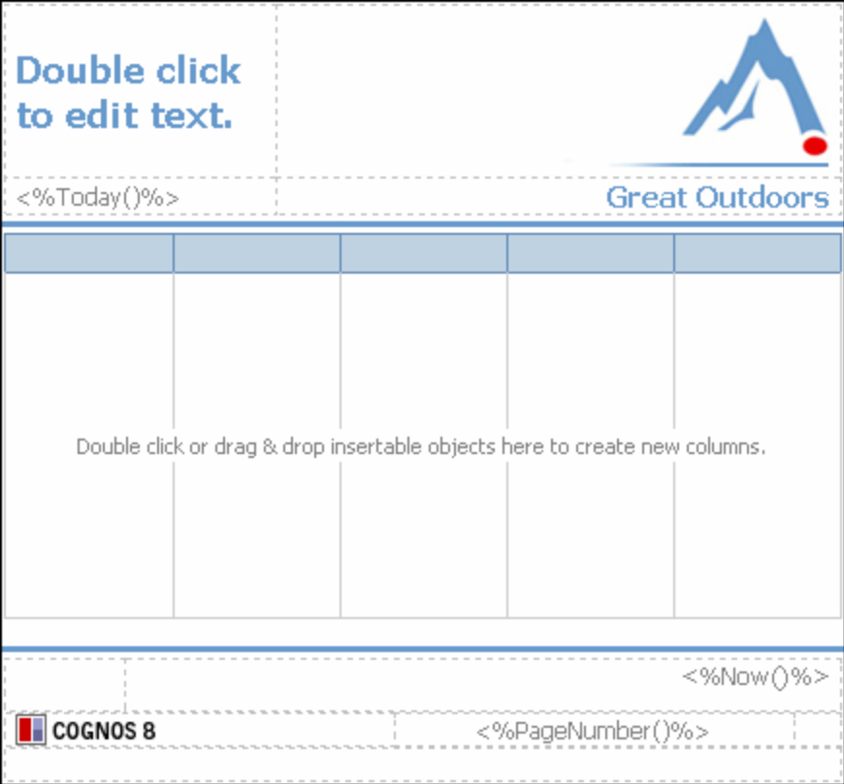

- Steps

- Create a new blank report, but do not add data to it.
- Add a page header.
- Add a border to the bottom of the header. Make the border 2-1/4 pts and apply the Web-safe color #6699CC.
- Add a table that has two columns and two rows.
Tip: Use the Toolbox tab in the Insertable Objects pane.
- Add a text item to the top-left cell of the table, and format it as Tahoma, 14 pt, bold, and
apply the Web-safe color #6699CC.
- Add the date to the bottom-left cell of the table, and format it as Tahoma, 9 pt, gray.

- Add this sample image to the top-right cell and align the image to the right:
..\samples\images\logo.jpg
- Add this text item to the bottom-right cell:
Great Outdoors
- Format the Great Outdoors text as Tahoma, 11 pt, bold. Apply the Web-safe color #6699CC.
Align the text to the right.
- Add a page footer.
- Add the same border to the top of the footer as you added to the header.
- Add a table that has three columns and three rows.
- Merge the second and third cells in the first row.
- Merge all cells in the third row.
- Add the time to the top-right cell of the table, and align it to the right.
- Add the page number to the middle-center cell of the table, and align it to the center.
- Format the time and page number as Tahoma, 9 pt, gray.
- Add this sample image to the middle-left cell:
..\samples\images\banner_cogsquare.jpg
- Add a list report to the report body, and center the list report.
- Convert the Report to a Template.
- Save the template, and use it as the starting point for a report.

Lab 35 - Try It Yourself - Create an Invoice

- Objective

Combine a list report, tables, text, and an image to create an invoice.
In this topic, you learn how to create an invoice that shows each customer’s order.
It should take 30 to 40 minutes to complete this topic, and your invoice will look like this.

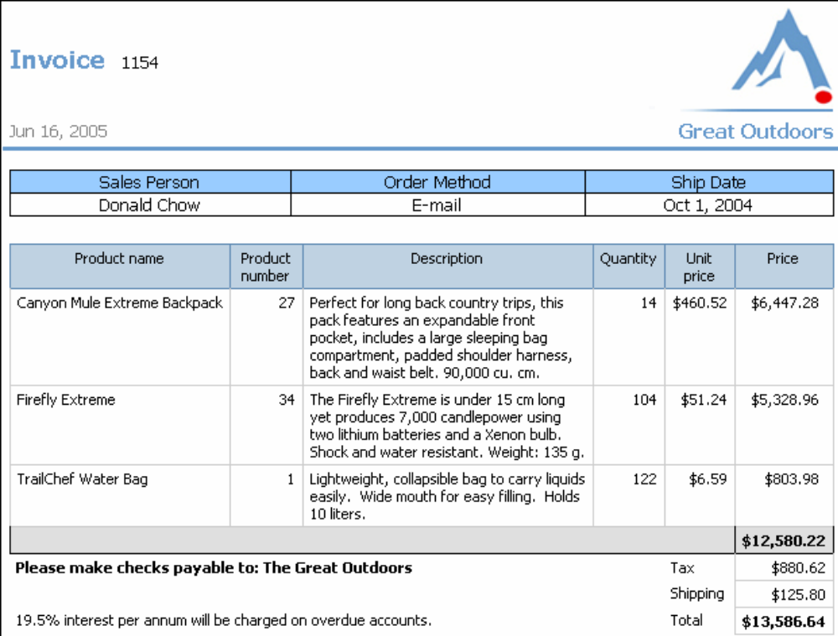

Get Started

- Create a new blank report that uses the sample package named GO Sales and Retailers.
- Change the font for the entire page to Arial.
Define the Page Header
- Add a page header to the report.
- Add a table with two vertical bands (columns) and two horizontal bands (rows).
- Add this text to the top left cell and format it (we used the Tahoma font, 14 point, and a
Web-safe blue):
Invoice
- Add the date to the bottom left cell.
- Add this sample image to the top right cell:
..\samples\images\logo.jpg
- Add this text to the bottom right cell and format it (we used the Tahoma font, 11 point, and a Web-safe blue):
Great Outdoors
- Add a border to the header.
- Set the bottom padding to 10 pixels.

Associate the Page with a New Query

- In the Query Explorer view, create a new query and add Order number (in Orders) as a
dimension.
- In the Report Pages view, create a new page set and add the new query to the Data properties of the page set. This means that you can add a data item anywhere in the report.
- Add the Order number to the header, next to Invoice.
- Group Order number.
- Change the data format for the Order number to not have a comma.

Set Up the Page Body

- Add a block to the page body.
- Change the top padding for the block to 10 pixels.
- Add a table with two rows and three columns to the block. The table must be the maximum
width and have a border.
- Add a block after the table.
- Change the top padding for the bottom block to 20 pixels.
- Change the background color of the first row of the table to purple.
- Center the text in the table.
- Add a list below the bottom block that you added.

Add Data to the Page Body

- Add text items to the first row of the table and use this text for each one:
  - Sales Name
  - Order Method
  - Ship Date
- Add these data items to the second row of the table:
  - Staff name (in Sales reps)
  - Order method (in Orders)
  - Order date (in Orders)
Tip: Use the Source tab in the Insertable Objects pane.
- Change the Data Format property for the Ship Date column to be a date only, not date and
time.
- Add these data items to the list report:
  - Product name (in Products)
  - Product number (in Products)
  - Description (in Products)
  - Quantity (in Orders)
  - Unit price (in Orders)
- Add this query calculation as a column and name it Price:
[gosales_goretailers].[Order details].[Quantity]*[gosales_goretailers].[Order details].[Unit
price]
- Change the Aggregate Function property for the Quantity column to None.
- Change the Aggregate Function property for the Unit price column to None.

Add Information at the Bottom of Each Invoice

- Add an overall footer to the list.
- Add a subtotal to the Price column.
- Insert a row and add a query calculation named Tax to the new row:
([gosales_goretailers].[Orders].[Quantity]*[gosales_goretailers].[Orders].[Unit price])*0.07
- Add this text item next to Tax and bold the text:
Please make checks payable to: The Great Outdoors
- Merge the cells next to the Tax label so that the text item has more room.
- Insert a row and add a query calculation named Shipping to the new row:
([gosales_goretailers].[Orders].[Quantity]*[gosales_goretailers].[Orders].[Unit price])*0.01
- Remove the borders from the cells to the left of the Shipping label.
- Insert a row and add a query calculation named Total to the new row:
([gosales_goretailers].[Orders].[Quantity]*[gosales_goretailers].[Orders].[Unit price])*1.08
- Add this text item next to the Total and then bold and center the text:
19.5% interest per annum will be charged on overdue accounts.
- Merge the cells next to the Total label so that the text item has more room.
- Run the invoice to view what it will look like for your users.

